Contact
Shari Lake
Director of Marketing
Coperion K-Tron Salina, Inc.
606 North Front Street
Salina, KS 67401 USA

Tel +1 (785) 825-3884
slake@coperionktron.com
www.coperionktron.com

Press release

Coperion K-Tron Introduces Unique New Electronic Pressure Compensation for Its High-Accuracy Loss-in-Weight Feeders

Niederlenz, Switzerland (February 2016) --- Coperion K-Tron has introduced a unique new Electronic Pressure Compensation (EPC) system for their high-accuracy loss-in-weight feeders. The main advantages of the new system include improved accuracy and reliability as well as lower initial cost and easier installation compared to traditional mechanical pressure compensation systems. Retrofitting options for existing feeders are available. EPC can be installed on a majority of Coperion K-Tron gravimetric feeders in almost any application and all industries.

In a closed feeding system, pressure build-up inside a feeder can significantly impair weighing accuracy. The commonly installed mechanical pressure compensation systems are sensitive to structural factors and machine alignment and may therefore be intricate or even unreliable. Coperion K-Tron has now developed a clever but simple electronic solution for accurate and steady pressure compensation in feeder hoppers. The modular design incorporates pressure sensors and electronics tailored to interact smoothly with Coperion K-Tron’s KCM feeder control system.
Depending on set-up and requirements, sensors can be positioned on the feeder hopper and, if required, on the material discharge tube. The software implements a self-optimizing compensation algorithm for best performance and dynamics identical to those of Coperion K-Tron’s SFT load cells, which allows for highly accurate feeding results, even in systems with perceivable pressure fluctuations.
A separate field evaluation kit allows for the assessment of potential pressure issues in existing installations.

Coperion K-Tron (www.coperionktron.com) is a business unit of Coperion (www.coperion.com) and is a global leader and single source supplier of material handling and feeding systems. Coperion K-Tron has defined the leading edge of technology for material handling and feeding applications in the process industries.

Coperion (www.coperion.com) is the international market and technology leader in compounding systems, feeding technology, bulk materials handling systems and services. Coperion designs, develops, manufactures and maintains systems, machines and components for the plastics, chemicals, pharmaceutical, food and minerals industries. Within its four divisions – Compounding & Extrusion, Equipment & Systems, Material Handling and Service – Coperion has 2,500 employees and nearly 40 sales and service companies worldwide.


Dear Colleagues,
This press release in English and German
and the color photos in printable quality are available for download from
http://www.coperion.com/en/news/newsroom/

Editorial contact and voucher copies:
Dr. Georg Krassowski, KONSENS Public Relations GmbH & Co. KG,
Hans-Kudlich-Straße 25, D-64823 Groß-Umstadt
Phone: +49 (0)60 78/93 63-0, Fax: +49 (0)60 78/93 63-20
E-Mail: mail@konsens.de, Internet: www.konsens.de

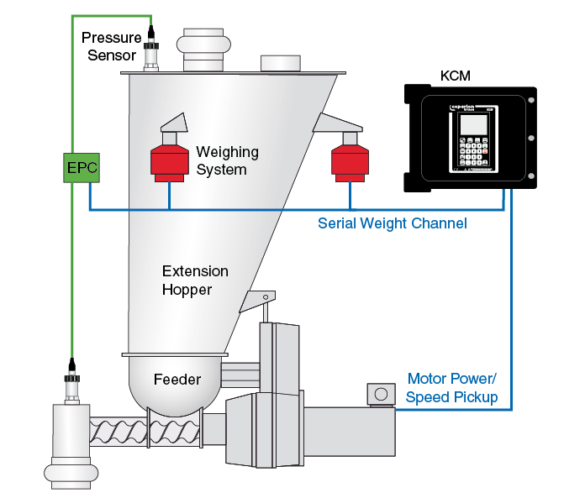

Basic principle of EPC electronic pressure compensation applied in gravimetric feeding system in a schematic presentation; KCM: feeding control

Image: Coperion K-Tron (Switzerland) GmbH, Niederlenz, Switzerland

