Contact
Shari Lake
Director of Marketing
Coperion K-Tron Salina, Inc.
606 North Front Street
Salina, KS 67401 USA

Telephone +1 (785) 825-3884
slake@coperionktron.com
www.coperion.com
www.coperionktron.com

Press Release

Coperion awarded prestigious Innovations Award from The International Dairy Foods Association
Sewell, NJ, USA (October 2015) – Coperion was awarded the Food Safety Innovations Award for their CIP design WYK Diverter Valve at the 2015 International Dairy Show which was held in Chicago, Il, USA, September 15-18, 2015.
One winner was selected in each of five categories of innovation – (1) food safety, (2) ingredients/flavorings/seasonings/additives, (3) packaging, (4) processing and (5) sustainability. Attendees of the International Dairy Show voted to select the winner of the Attendee Choice Award.
“The winners of the International Dairy FA Innovations Awards are responsible for crucial developments in technology and innovative products and services that keep this industry on the cutting-edge,” said Robin Cornelison, trade show director at IDFA. “We are proud to highlight the creativity of these six winning companies that are leading the way for the industry in 2015.”

About the WYK Two-Way-Diverter Valve
The patent-pending design of the WYK Diverter Valve incorporates an innovative retractable rotor assembly and is completely designed in accordance with European Hygienic Engineering and Design Group (EHEDG) guidelines. This design permits the automatic cleaning of pneumatic conveying pipes. The valve is the first and only one of its kind available on the market.
The WYK Two-Way Diverter Valve is ideally suited for inline material handling of hygienic and difficult to handle powders, such as whey powder, lactose, dried milk powders and infant formula. This valve can be used in pneumatic conveying systems, in order to divert transfer of the powder to different locations, and it is often used in return lines in spray drying applications. The fully automatic CIP cleaning design permits complete purging of all product residues after the automatic cleaning process. Due to a unique retractable rotor assembly, the rotor can be pulled slightly out of the housing towards the rear of the valve, thus allowing the cleaning solution to rinse all product contact surfaces within the valve. In addition, specialty purge openings in the actuator plate enable an intense rinsing flow and complete discharge of the rinsing effluent.

Coperion (www.coperion.com) is the international market and technology leader in compounding systems, feeding technology, bulk materials handling systems and services. Coperion designs, develops, manufactures and maintains systems, machines and components for the plastics, chemicals, pharmaceutical, food and minerals industries. Within its four divisions – Compounding & Extrusion, Equipment & Systems, Materials Handling and Service – Coperion has 2,500 employees and nearly 40 sales and service companies worldwide. Coperion K-Tron (www.coperionktron.com) is a brand of Coperion.



Dear Colleagues,
This press release in English and German
and the color photos in printable quality are available for download from
http://www.coperion.com/en/news/newsroom/

Editorial contact and voucher copies:
Dr. Georg Krassowski, KONSENS Public Relations GmbH & Co. KG,
Hans-Kudlich-Straße 25, D-64823 Groß-Umstadt
Phone: +49 (0)60 78/93 63-0, Fax: +49 (0)60 78/93 63-20
E-Mail: mail@konsens.de, Internet: www.konsens.de

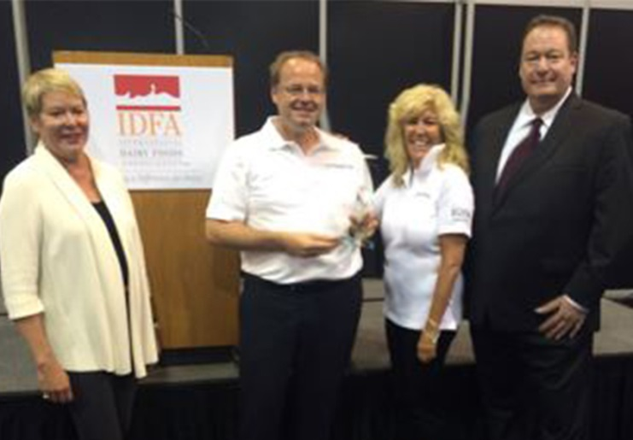

Picture Left to Right:
Connie Tipton, President and CEO of IDFA; Jochen Sprung, Business Development Manager for Food Components at Coperion; Sharon Nowak, Global Business Development Manager for Food & Pharma, Coperion K-Tron; and Tom Imbordino, Publisher of Dairy Foods magazine.

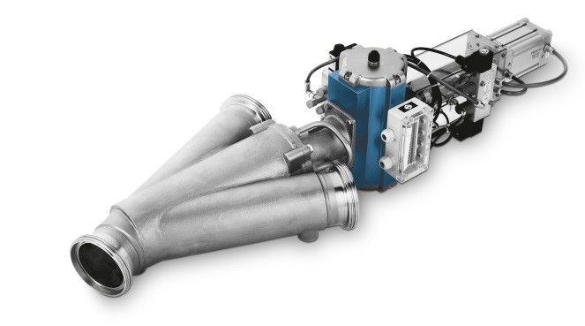
Coperion’s WYK Two-Way Diverter Valve is ideally suited for inline material handling of hygienic and difficult to handle powders, such as whey powder, lactose, dried milk powders and infant formula.
Image: Coperion, Weingarten, Germany

