Contact
Bärbel Henning
Marketing Communications
Coperion GmbH
Theodorstrasse 10
70469 Stuttgart / Germany

Phone +49 (0)711 897 31 57
Fax +49 (0)711 897 39 81
baerbel.henning@coperion.com
www.coperion.com

Press Release

3rd “Food Extrusion Seminar” at Coperion – hands-on insight into a special application

Stuttgart, November 2015 – Organized by Coperion in close collaboration with the German Institute of Food Technologies (DIL), Quakenbrück, (www.dil-ev.de), the third “Food Extrusion Seminar” took place on the premises of Coperion GmbH in Stuttgart on Sept. 30 and Oct. 1, 2015. Attracting keen interest from near and far, the organizers welcomed as many as 35 guests from all parts of the world to this in-depth seminar. Most of the participants came from the production and product development departments of food companies. Lecturers from Coperion, Coperion K-Tron and the DIL and guest lecturers from Vibra Maschinenfabrik Schultheis GmbH & Co., Offenbach am Main, and the Technical University of Berlin illuminated the technical and technological aspects of food extrusion from all sides. The lectures were augmented by several practical practical workshops. One of the highlights of the seminar was a demonstration of “high moisture extrusion” for the processing of plant proteins into meat analogues. The contribution made by representatives of various scientific institutes included a lecture on current food extrusion research and several poster-presentations of their projects and findings.

The experts' lectures dealt both with the mechanical engineering aspects of extruders and their peripherals and with the technological and processing aspects of food extrusion itself. Having first been familiarized with the basics of extrusion, the participants were then given detailed information on the design configuration and function of a twin-screw extruder using a Coperion ZSK extruder as an example. Also explained, besides the ZSK with ZS-B side feeder and ZGF pelletizer, were the gravimetric feeders from Coperion K-Tron and the drying technology featured on the systems manufactured by Vibra Maschinenfabrik Schultheis.

The processing aspects of the individual stages of food extrusion, such as mixing, kneading, emulsifying, degassing and expanding, were explained in detail, as were the product-specific aspects of extruded food products and individual ingredients. The practical part of the seminar took place in Coperion's Test Lab, where participants could now see what they had learned being put into actual practice in trials carried out on two ZSK extruders (a ZSK 27 MEGAvolume PLUS with 27 mm diameter screws and a ZSK 43 MEGAvolume with 43 mm diameter screws).

The production of high moisture meat analogues was demonstrated on the ZSK 27 MEGAvolume PLUS laboratory extruder equipped with an innovative cooling die, which has been designed especially for the production of meat substitutes from plant protein concentrate. With its low throughput rates and relatively small size, the ZSK 27 Mv PLUS extruder offers optimum scale-up possibilities for food extrusion on a production scale. The ZSK Mv PLUS series optimally combines a large free volume with high screw speeds of up to 1800 rpm and is thus ideal for the extrusion of both meat analogues and conventional food products.

The second extrusion line, consisting of a ZSK 43 Mv, two gravimetric feeders for solids and a liquid metering pump from Coperion K-Tron, demonstrated the production of breakfast cereals. In the course of this demonstration, the participants were shown how the process can be influenced by different extrusion parameters and ingredients. The demonstration program in the Coperion Test Lab was rounded off with a comprehensive display of almost a hundred various extruded product samples from all sectors of the food industry and a tasting session permitting participants to try various high-moisture meat-analogue products for themselves. Participants were also able to put theory into practice in small groups, the set task being the “threading” of screw elements onto the screw shafts.

The participants were highly satisfied with the seminar: “Professional, well organized event” – “Well done” – “For me the seminar was a very positive experience, with a good balance between lectures and practical sessions” – are examples of comments made by the guests. This seminar program is to be continued in 2016.

Coperion (www.coperion.com) is the international market and technology leader in compounding systems, feeding technology, bulk materials handling systems and services. Coperion designs, develops, manufactures and maintains systems, machines and components for the plastics, chemicals, pharmaceutical, food and minerals industries. Within its four divisions – Compounding & Extrusion, Equipment & Systems, Materials Handling and Service – Coperion has 2,500 employees and nearly 40 sales and service companies worldwide.

The German Institute of Food Technologies (DIL), Quakenbrück and Brussels, is located at the heart of Germany’s agriculture and food industry (www.dil-ev.de). A very well-established team of around 150 experts has been developed in connection with the institute over the past three decades. The team taps new potentials every day and paves the way for innovations. With more than 150 member companies from the food industry and related fields, DIL operates as a research institute working in the areas of product development, process development and analysis. The institute’s competences and technical capabilities span the full range of food technologies.

Dear Colleagues,
This press release in German and English
and the colour photos in printable quality are available for download from
http://www.coperion.com/en/news/newsroom/

Editorial contact and voucher copies:
Dr. Georg Krassowski, KONSENS Public Relations GmbH & Co. KG,
Hans-Kudlich-Straße 25, D-64823 Groß-Umstadt
Phone: +49 (0)60 78/93 63-0, Fax: +49 (0)60 78/93 63-20
E-Mail: mail@konsens.de, Internet: www.konsens.de

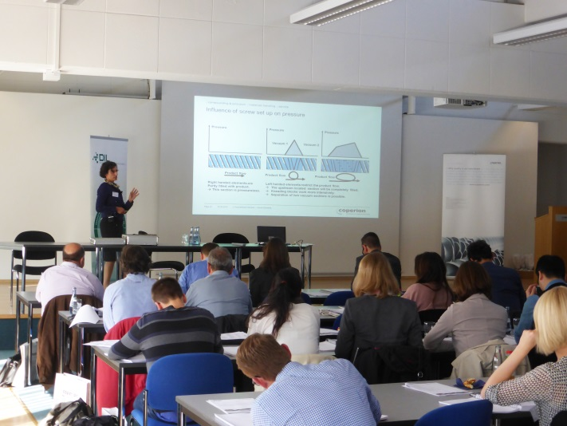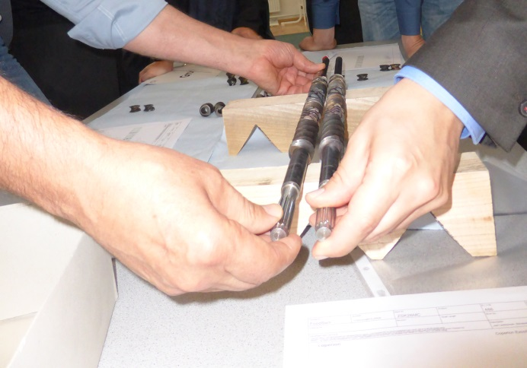

The Food Extrusion Seminar 2015 at Coperion combined expert lectures (left) with practical demonstrations and exercises. Photo on right: Participants practicing screw configuration by “threading” various screw elements (conveying, mixing, shearing) onto the screw shafts.

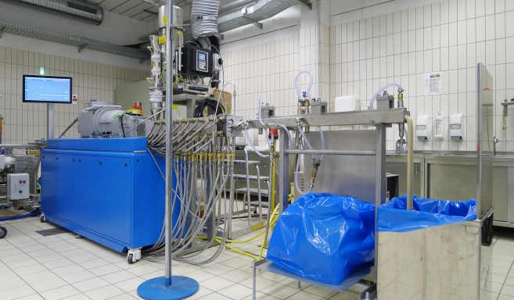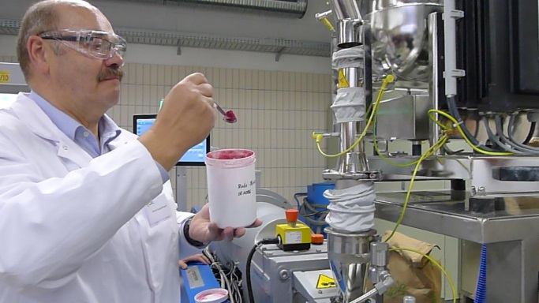

ZSK 27 MEGAvolume PLUS with KT 20 feeder (Coperion K-Tron) fitted with cooling die (DIL). Practical demonstration: High-moisture extrusion cooking of newly developed meat analogues (photo left). Colored additives were used in order to visualize the process (photo right).
Photos: Coperion, Stuttgart

