Kontakt
Julia Conrad
Marketing & Communications
Coperion GmbH
Theodorstrasse 10
70469 Stuttgart / Germany

Phone +49 (0)711 897 22 25
Fax +49 (0)711 897 39 81
Julia.conrad@coperion.com
www.coperion.com

Press Release

5th Food Extrusion Seminar at Coperion Stuttgart – Practice-oriented insight into food extrusion

Stuttgart, November 2016 – The Food Extrusion Seminar that Coperion GmbH, Stuttgart, Germany, organizes in partnership with the German Institute of Food Technologies (DIL) in Quakenbrück (www.dil-ev.de) took place for the fifth time in Stuttgart on November 8-9, 2016. More than 40 participants from around the globe attended the two-day, in-depth seminar. Beyond the basics, the participants received information on the latest technical developments and trends in the food extrusion from the experts from Coperion, Coperion K-Tron and DIL. Specialists from Vibra Maschinenfabrik Schultheis GmbH & Co. and the Karlsruhe Institute of Technology illuminated the technical and technological aspects of food extrusion from all sides. In addition to the lectures, there were several interactive practical units. A seminar highlight was the demonstration of high moisture extrusion, in which vegetable proteins are processed into meat analogues.

In their lectures, the experts talked about the mechanical engineering aspects of extruders and their peripherals, and detailed the technological aspects and processes of food extrusion. After starting with the extrusion basics, they showed the detailed design and function of a twin-screw extruder, using a Coperion ZSK extruder as an example. They also provided the participants with information on feeding a wide variety of ingredients. The process engineering aspects of the individual process steps of food extrusion such as mixing, kneading, emulsifying, degassing and expanding were explained in detail, as well as the product-specific aspects of extruded food products. Uta Kühnen from Coperion and Dr. Stefan Töpfl from DIL also gave talks on the subject of recipe constituents: which ingredients affect in which manner recipe and process to obtain the desired product properties.

The practical part of the seminar took place in Coperion's Test Lab, where participants could now see what they had learned being put into actual practice in trials carried out on two ZSK extruders (a ZSK 27 MEGAvolume PLUS with 27 mm diameter screws and a ZSK 43 MEGAvolume PLUS with 43 mm diameter screws).

On the ZSK 27 Mv PLUS laboratory extruder, the DIL experts demonstrated how to produce high moisture meat analogues from a protein concentrate. The extruder was equipped with an innovative cooling die developed by the DIL that received the DLG International FoodTec Award Gold in 2015. Although designed for low throughput rates and small sizes, the ZSK 27 Mv PLUS extruder offers optimal scale-up possibilities for food extrusion on a production scale. The ZSK Mv PLUS series optimally combines a large free volume with high screw speeds of up to 1800 rpm. It is ideal for the extrusion of both meat analogues and conventional food products.

A second extrusion line with a ZSK 43 Mv PLUS, two gravimetric feeders for solids and a liquid metering pump from Coperion K-Tron was used to demonstrate cooking extrusion of breakfast cereals. In the course of this session, the experts showed the influence of different extrusion parameters and recipe constituents on the process. Together with the seminar participants, they measured extrudate and verified the quality and output parameters at different settings. A comprehensive display of around 100 different extrudate samples from all sectors of the food industry and tasting various high-moisture meat analogue end products rounded out the program in the Coperion Test Lab.

“During the intensive, two-day seminar, we conveyed important information on the subject of food extrusion to the participants and informed them of current trends and developments. And the interactive practice-oriented units gave them the opportunity to apply what they learned. A successful mixture that we will probably continue in 2017,” said Frank Lechner, Head of Process Technology at Coperion in Stuttgart.

Coperion (www.coperion.com) is the international market and technology leader in compounding systems, feeding technology, bulk materials handling systems and services. Coperion designs, develops, manufactures and maintains systems, machines and components for the plastics, chemicals, pharmaceutical, food and minerals industries. Within its four divisions – Compounding & Extrusion, Equipment & Systems, Materials Handling and Service – Coperion has 2,500 employees and nearly 40 sales and service companies worldwide.

The German Institute of Food Technologies (DIL), Quakenbrück and Brussels, is located at the heart of Germany’s agriculture and food industry (www.dil-ev.de). A very well-established team of around 150 experts has been developed in connection with the institute over the past three decades. The team taps new potentials every day and paves the way for innovations. With more than 150 member companies from the food industry and related fields, DIL operates as a research institute working in the areas of product development, process development and analysis. The institute’s competences and technical capabilities span the full range of food technologies.

Dear Colleagues,
This press release in German and English
and the colour photos in printable quality are available for download from
http://www.coperion.com/en/news/newsroom/

Editorial contact and voucher copies:
Dr. Jörg Wolters, KONSENS Public Relations GmbH & Co. KG,
Hans-Kudlich-Straße 25, D-64823 Groß-Umstadt
Phone: +49 (0)60 78/93 63-0, Fax: +49 (0)60 78/93 63-20
E-Mail: mail@konsens.de, Internet: www.konsens.de

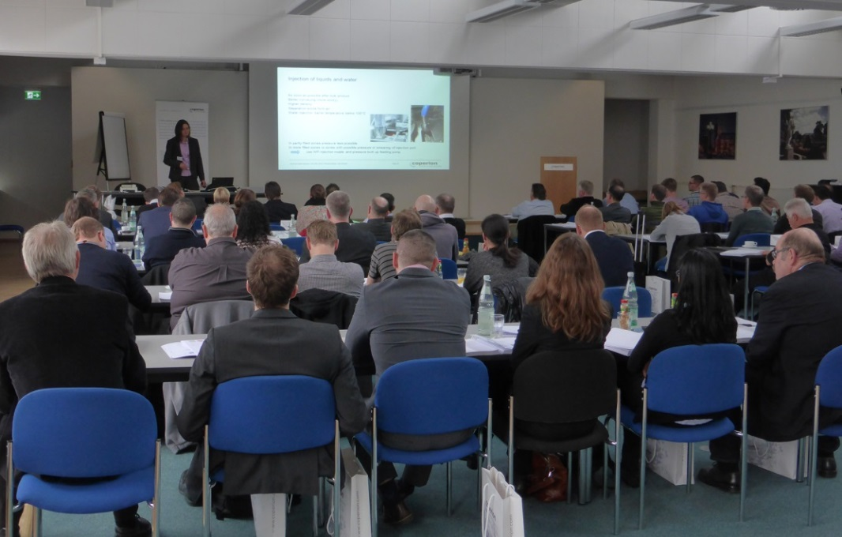

The Food Extrusion Seminar 2016 at Coperion combined expert lectures with practical demonstrations and exercises.
Image: Coperion, Stuttgart

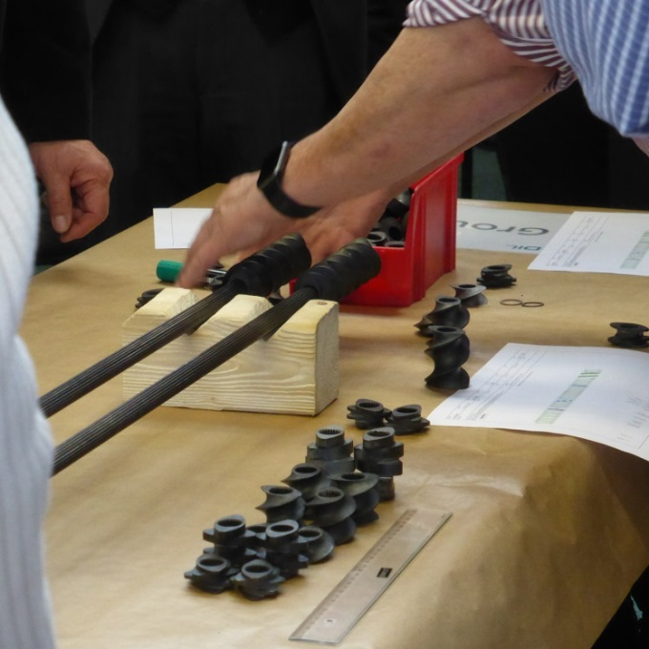

Participants practicing screw configuration by “threading” various screw elements (conveying, mixing, shearing) onto the screw shafts.
Image: Coperion, Stuttgart
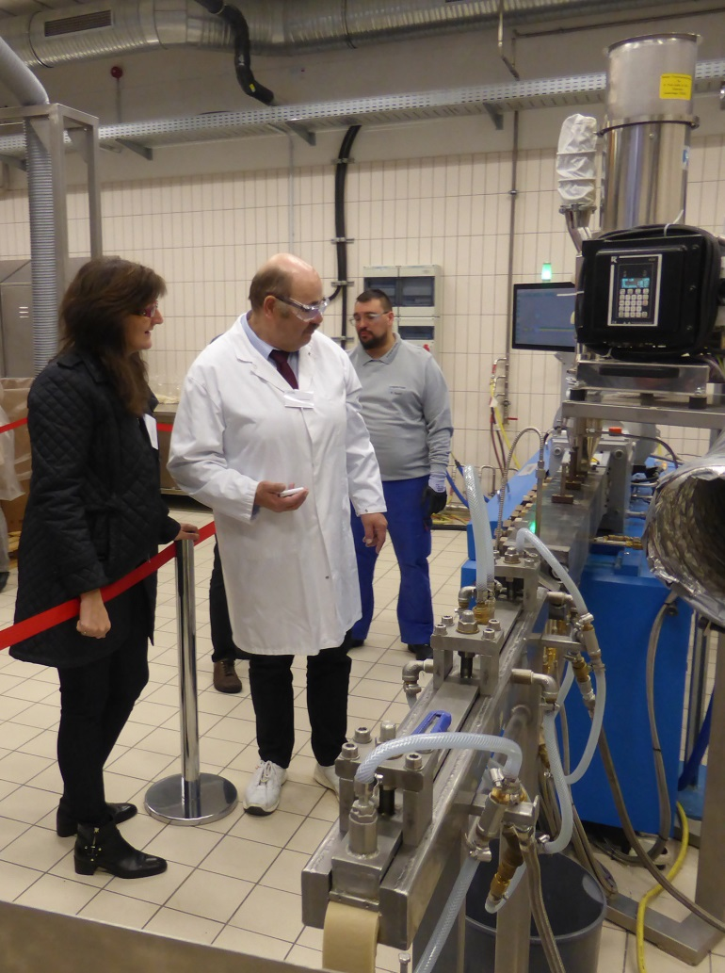

A seminar highlight was the demonstration of high moisture extrusion, in which vegetable proteins are processed into meat analogues.
Image: Coperion, Stuttgart

