Contact
Shari Lake
Marketing Communications
Coperion & Coperion K-Tron
606 N Front St
Salina, KS 67401 USA

Tel.: +1 (785) 531-1528
shari.lake@coperion.com
www.coperion.com

West Hall Level 2, Booth W1181

Press release

Coperion and Schenck FPM Present Together at NPE 2024

Two Strong Industry Players Join Forces at NPE 2024
Together We Make It Work

Salina, KS, USA, March 2024 – At NPE 2024 (May 6-10, 2024, Orlando, Florida / USA), Coperion and Schenck Process Food and Performance Materials (FPM) will present together for the very first time a variety of feeding, dust collection, pneumatic conveying, and bulk material handling components, representing their complete system solutions for plastic processors at Booth W1181 in West Hall Level 2. By combining the complementary strengths of Coperion and Schenck Process FPM the two trusted and reliable industry players offer enhanced comprehensive system solutions to customers around the world.

A distinct benefit of the Coperion and Schenck Process FPM merger is the ability to combine the competencies of the two companies. A virtual plant at the booth demonstrates how the partnership offers true complete system solutions. Another showstopper will be the preconfigured ProRate™ PLUS-MT feeder that will be presented for the first time at NPE. The new feeder is representative of first-class compounding technology and process solutions.

After visiting Booth W1181, make your way over to Booth W1601 and checkout what Coperion and Herbold Meckesheim are displaying for plastics recycling and polyolefin applications. Here, you will find the Schenck Process FPM MechaTron® Flat Bottom (FB) feeder. This high-capacity stainless steel feeder is designed specifically for handling materials with light and fluffy characteristics. With a bottom driven vertical agitator and an auxiliary agitator, the MechaTron FB is perfect for hard to feed materials such as chopped polypropylene or PET plastic film when feeding to an extruder.

Stop by and see for yourself how Coperion and Schenck Process FPM are committed to and value their industry partnerships when they say, “Together We Make It Work”.

Complete Systems from a Single Source
Along with proven high-performance and durable components, Coperion and Schenck Process FPM can supply an entire system for plastic processors. Combined solutions for the ideal compounding process will be part of a virtual display at NPE 2024. From rail and bulk unloading, through pneumatic transport of materials, various weighing and feeding technologies, to processing in a Coperion extruder, this 3D animation will show the material as it moves through the various steps to become a high-performance resin.

Smart Feeding Solutions for More Possibilities than Ever Before
At the booth and at Booth W1601, attendees can see firsthand a full range of feeders with options for every application. Both Coperion and Schenck Process FPM are industry leaders in accurate and reliable feeding applications and this year’s feeding exhibits will not disappoint.
Coperion has expanded the ProRate PLUS feeder line with a PLUS-MT twin screw version that is a perfect match for feeding additive powders in the plastics industry. This gravimetric feeder with its horizontal agitator ensures that the two screws are always optimally filled with material. The twin screw technology also has the advantage of reducing pulsations and the screws have a self-cleaning effect. Twin screw feeders are ideal for difficult to handle powder additives such as talc, calcium carbonate or carbon black.

The Schenck Process FPM MechaTron® dry material feeder has all the unique design features that manufacturers require for their processing applications. Complete disassembly from the non-process side of the feeder eliminates the need to remove upper extension hoppers, bins, bulk bags, and IBC’s to clean or maintain the feeder. Flexible or all stainless steel hoppers are available to accommodate any unique dry material feeding application. MechaTron feeders are perfectly suited to handle a wide range of volumetric or gravimetric feeding applications for bulk solid materials.

Last but not least when it comes to the feeder exhibits in the booth, is the Coperion K-Tron T35 Quick Change screw feeder. The K2-ML-T35-QC model on display represents the ease of the interchangeable feeding tools and the simplicity of disassembly. The T35 is designed for free flowing to very poor flowing powders (e.g., lumpy, moist or bridge building materials) as well as fibers, flakes and other bulk materials.

Learn What Drives Our Rotary Valves and Airlocks
The Coperion ZRD 400 rotary valve is specifically designed for plastics, mineral and chemical applications. The valve on display is a demonstration valve representing several special variations including multiple rotor blade configurations, quick clean options and wear concepts. The ZRD is often used as a discharging and metering valve for conveying products in powder and granular form.
With tens of thousands of installations throughout the world, the Schenck Process FPM Multi-Duty (MD) airlock is a highly universal airlock used to meter dry bulk materials under feeding devices, such as bins, hoppers, mixers, screw conveyors and sifters. Providing rugged service, the MD Airlock is suitable for use in dilute phase vacuum, pressure or combination vacuum/pressure pneumatic conveying systems. Low mounting height is ideal for space restricted applications. MD Airlocks are rated up to 15 psi pressure differential and can handle temperatures up to 200 °F (93 °C).
Low Rate Vacuum Receiver Provides Highly Accurate and Controlled Flow of Materials
The Low Rate Vacuum (LRV) Receiver is an NFPA compliant, 1.8 ft³ (50L) capacity vacuum conveying system that offers a cleaner operating environment for handling both raw materials and finished products. It can be easily integrated into a wide range of production processes, including extruder lines, small injection, blow molding and film producing processes. It is also ideal for handling minor additives for mixing and PVC blending towers. The LRV contributes to a highly accurate and controlled flow of materials in these applications.

For complete show highlights, visit www.coperion.com/NPE2024/W1181
Coperion (www.coperion.com) is a global industry and technology leader in compounding and extrusion systems, sorting, size reduction and washing systems, feeding systems, bulk material handling and services. Coperion develops, produces, and services plants, machinery, and components for the plastics and plastics recycling industry as well as the chemical, batteries, food, pharmaceutical and minerals industries. Coperion employs more than 5,000 people in its three divisions, Polymer, Food, Health & Nutrition, and Aftermarket Sales & Service, and in its over 50 sales and service companies worldwide. Coperion is an Operating Company of Hillenbrand (NYSE: HI), a global industrial company that provides highly-engineered, mission-critical processing equipment and solutions to customers serving a wide variety of industries around the world. www.hillenbrand.com

Schenck Process Food and Performance Materials (FPM) - part of Coperion, a Hillenbrand company, engineers cutting-edge technologies and solutions across the bulk material handling spectrum. Our teams deliver complete solutions for your real-world needs, based on deep process and engineering expertise. We specialize in precision solutions for pneumatic conveying, milling, dust collection, sifting, weighing, and feeding. Schenck Process FPM and Coperion boast a streamlined business model which enables us to deliver high-performing systems for customers in every corner of the world, supported by an extensive collection of services. www.schenckprocessfpm.com

Dear colleagues,
You can download this press release in English, Spanish and German and
the colored photos in printable quality from the Internet at
https://www.coperion.com/en/news-media/newsroom/
.
Editor contact and copies:
Dr. Jörg Wolters, KONSENS Public Relations GmbH & Co. KG,
Hans-Böckler-Str. 20 D-63811 Stockstadt am Main
Tel.: +49 (0) 6027/99005-13
E-mail: mail@konsens.de, Internet: www.konsens.de

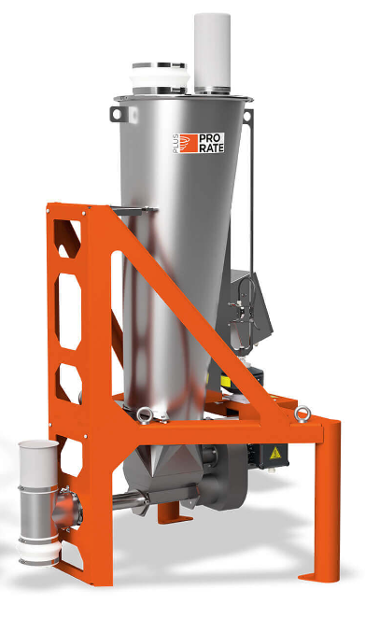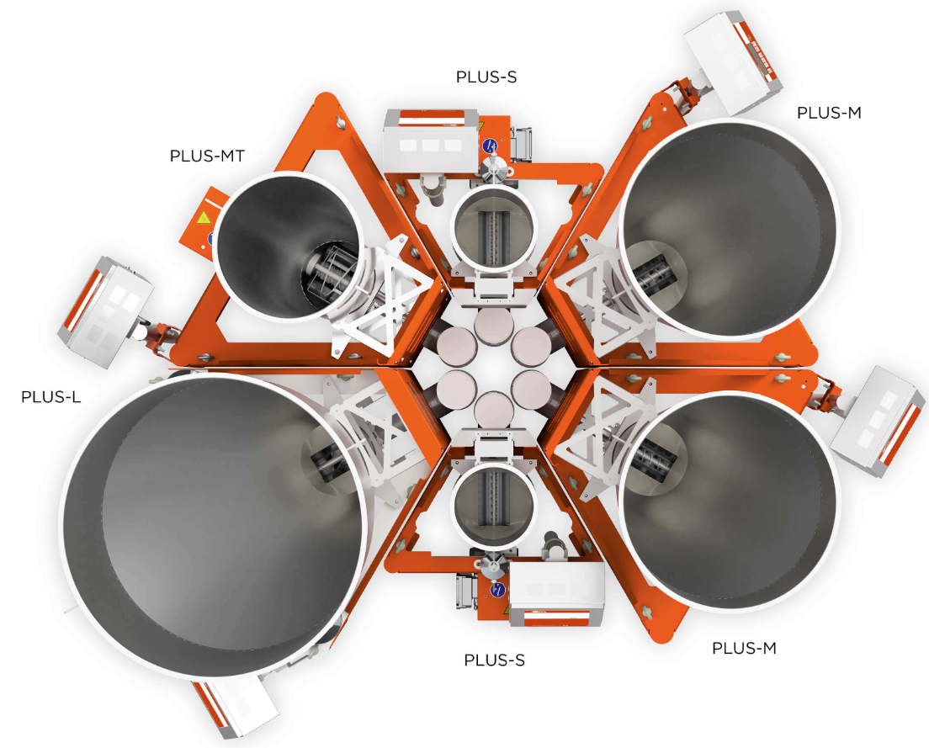
The ProRate PLUS-MT feeder comes mounted in its own stand so it can either be installed individually or combined with other ProRate PLUS feeders to form a compact cluster without the need of an additional structure.
Image: Coperion K-Tron, Salina, KS

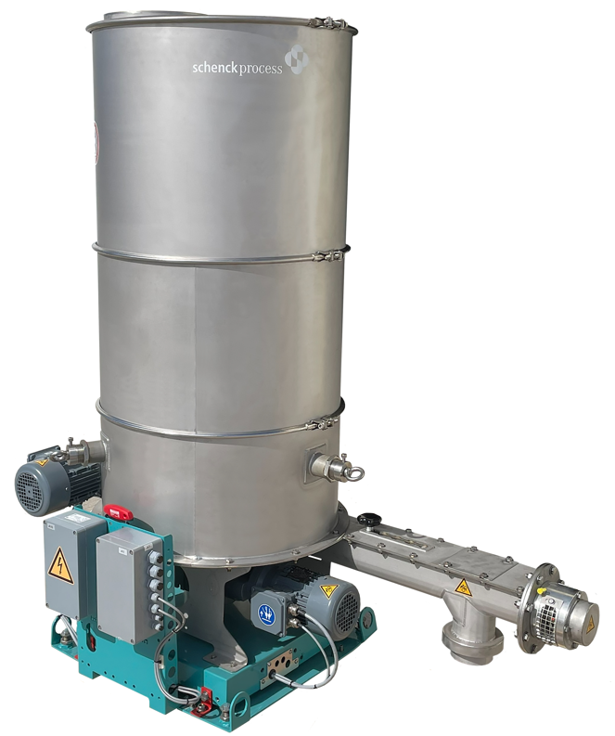
The Schenck Process FPM MechaTron® Flat Bottom (FB) feeder is ideal for feeding low bulk density materials such as chopped films and scrap.
Image: Schenck Process FPM, Whitewater, WI

