Contact
Bettina König
Marketing Communications
Coperion GmbH
Theodorstrasse 10
70469 Stuttgart/Germany

Phone +49 (0)711 897 22 15
Fax +49 (0)711 897 39 74
bettina.koenig@coperion.com
www.coperion.com

West Hall Level 2, Booth W1601

Press release

Coperion and Herbold at NPE 2024

Smart Solutions for Plastics Recycling and Compounding
Sewell, NJ, USA, March 2024 – At NPE 2024 (May 6-10, 2024, Orlando, Florida / USA), Coperion and Herbold Meckesheim will present a variety of advanced components and solutions for plastics recycling and processing at their Booth W1601 in West Hall Level 2. As a raw material, plastic can make a valuable contribution to environmental protection, the energy revolution and a circular economy. The key is efficient recycling of plastics. For this reason, plastics recycling is the focus of comprehensive development projects at Coperion and Herbold Meckesheim. The two companies will show the results of these projects at NPE 2024 by presenting combined process solutions and technologies for the economical recycling of various plastics while achieving the highest levels of product quality. On display in the booth will be a ZSK 58 Mc¹⁸ twin screw extruder configured for manufacturing high-quality PET using recycled materials as well as the recently introduced ZS-B 70 MEGAfeed side feeder for lightweight fiber and flakes recycling and a Herbold Meckesheim HV70 plastcompactor. Also on display will be a new Schenck Process FPM MechaTron® Flat Bottom (FB) feeder, a high-capacity stainless steel feeder that is designed specifically for handling materials with light and fluffy characteristics such as films and scrap. More equipment for feeding, dust collection, pneumatic conveying, and bulk material handling components will be on display in the joint Coperion and Schenck Process FPM Booth W1181.
From Single Components to Entire Plants
With the combination of Coperion and Herbold Meckesheim technology and know-how, the two companies are able to provide efficient plastics recycling solutions from mechanical processing – shredding, washing, separating, drying, and agglomerating of plastics – to bulk material handling, feeding and extrusion, as well as compounding, pelletizing and odor reduction, to complete systems. Customers have access to individual components as well as complete recycling systems from a single source, supplying highest end product quality and throughputs. Since their merger, both companies have continued to develop and optimally attune their technologies so that entire systems excel in operation with extremely high efficiency.
ZS-B MEGAfeed Side Feeder Makes Plastics Recycling Significantly More Economical
For feeding voluminous flakes and fibers (PET and other plastics) efficiently into a ZSK twin screw extruder, Coperion will show the innovative, recently developed Coperion ZS-B 70 MEGAfeed side feeder. Plastic recyclate with a bulk density starting as low as 20 kg/m³, long considered intake-limited and thus not worth recycling, can be reliably fed in large quantities into smaller sizes of Coperion’s ZSK twin screw extruders and be concurrently recycled and compounded.
Conventional technologies for recycling PET require pre-drying and crystallization of flakes and fibers before they can be re-processed. Using Coperion's ZS-B 70 MEGAfeed side feeder, PET recyclate can be introduced directly into the ZSK extruder. Recyclers profit particularly from the very high end product quality. Thanks to the ZSK’s very good devolatilization properties, volatile components such as monomers, oligomers and water are reliably removed. Savings in operating and logistics costs as well as reduced energy consumption are further advantages of Coperion systems for recycling PET. The high quality of recycled PET manufactured using this innovative Coperion process was approved by the U.S. Food and Drug Administration (FDA) for direct contact with food (letter of non-objection).
Herbold Meckesheim HV 70 plastcompactor - High Bulk Density, Minimal Thermal Impact
The high-performance HV 70 plastcompactor, also on display in the booth, is the most powerful of the series from Herbold Meckesheim. It processes the feedstock in continuous operation between a rotating and a fixed compactor disk, which are equipped with screwed-on and easily exchangeable kneading bars. HV plastcompactors can be used to agglomerate a wide variety of materials into products of high bulk density: thermoplastics such as fibers, fine particles, small tapes, foams, stretch or thin films, powders or shavings, as well as plastics that are difficult to convey, stock or mix. The HV 70 moreover combines high throughput and low wear costs with a fully automatic control system in which settings for different feedstocks can be recorded. Thanks to performance and temperature monitoring, the process is controlled in such a way that only a minimum of personnel is required.

Schenck Process FPM MechaTron® Flat Bottom (FB) Feeder for Light and Fluffy Materials
Also on display will be the Schenck Process FPM MechaTron® Flat Bottom (FB) feeder. This high-capacity stainless steel feeder is designed specifically for handling materials with light and fluffy characteristics. With a bottom driven vertical agitator and an auxiliary agitator, the MechaTron FB is perfect for hard to feed materials such as chopped polypropylene or PET plastic film when feeding to an extruder. Since 2023 Schenck Process FPM is part of Coperion; both brands present their joint forces for the first time at this year’s NPE.
Chemical Recycling Solutions - For Large Amounts of Mixed Plastic Waste
Coperion’s twin screw extruder technology possess numerous advantages that are especially beneficial in chemical recycling of plastics. The technology is particularly well suited for an efficient energy addition and covers a broad range of throughputs. On larger ZSK extrusion machines, throughputs of up to 20 t/h ensure continuous feeding of the reactor.
Cameron Kheradi, Head of Process Technology at Coperion USA, said: “Plastics recycling is one of the core topics that we are emphatically promoting in order to better support the plastics industry on its path to a circular economy. We are very proud of our newly developed technologies and processes that achieve first-class product quality and make plastics recycling significantly more efficient. The innovative ZS-B MEGAfeed even makes it possible to recycle certain plastic fibers and flake in the first place. With our new Recycling Innovation Center, we have the optimal environment for developing further technologies and working together with our customers to optimize recycling processes.”
Coperion & Schenck Process FPM Booth W1181 – Focus on feeding, dust collection, pneumatic conveying, and bulk material handling components
In Booth W1601 Coperion and Schenck Process FPM will present together for the very first time a variety of feeding, dust collection, pneumatic conveying, and bulk material handling components as well as representing their complete system solutions for plastic processors. By combining the complementary strengths of Coperion and Schenck Process FPM, the two trusted and reliable industry players offer enhanced comprehensive system solutions to customers around the world.

For complete show highlights, visit www.coperion.com/NPE2024 www.coperion.com/NPE2024

Coperion (www.coperion.com) is a global industry and technology leader in compounding and extrusion systems, sorting, size reduction and washing systems, feeding systems, bulk material handling and services. Coperion develops, produces, and services plants, machinery, and components for the plastics and plastics recycling industry as well as the chemical, batteries, food, pharmaceutical and minerals industries. Coperion employs more than 5,000 people in its three divisions, Polymer, Food, Health & Nutrition, and Aftermarket Sales & Service, and in its over 50 sales and service companies worldwide. Coperion is an Operating Company of Hillenbrand (NYSE: HI), a global industrial company that provides highly-engineered, mission-critical processing equipment and solutions to customers serving a wide variety of industries around the world. www.hillenbrand.com

Herbold Meckesheim (www.herbold.com) is a leading recycling specialist and produces machines and plants for processing pure plastic waste from the industry as well as used, mixed and contaminated plastics. The modular system solutions for automated recycling lines are tested in the company's own technical center. More than 260 employees at the headquarters and the staff of the international agencies accompany custom-made plants and machines from the conception stage through commissioning to the end of their commercial use. Since 2022 Herbold Meckesheim is part of the new Recycling Business Unit of Coperion, which offers complete solutions for plastics recycling processing. Coperion is the global industry and technology leader in compounding and extrusion systems, feeding and weighing systems, bulk material handling and services. Coperion is an Operating Company of Hillenbrand (NYSE: HI), an industrial company operating in over 40 countries serving a wide variety of industries across the world. www.hillenbrand.com

Dear colleagues,
You can download this press release in English and German and
the colored photos in printable quality from the Internet at
https://www.coperion.com/en/news-media/newsroom/
.
Redaktioneller Kontakt und Belegexemplare:
Dr. Jörg Wolters, KONSENS Public Relations GmbH & Co. KG,
Hans-Böckler-Str. 20 D-63811 Stockstadt am Main
Tel.: +49 (0) 6027/99005-13
E-mail: mail@konsens.de, Internet: www.konsens.de

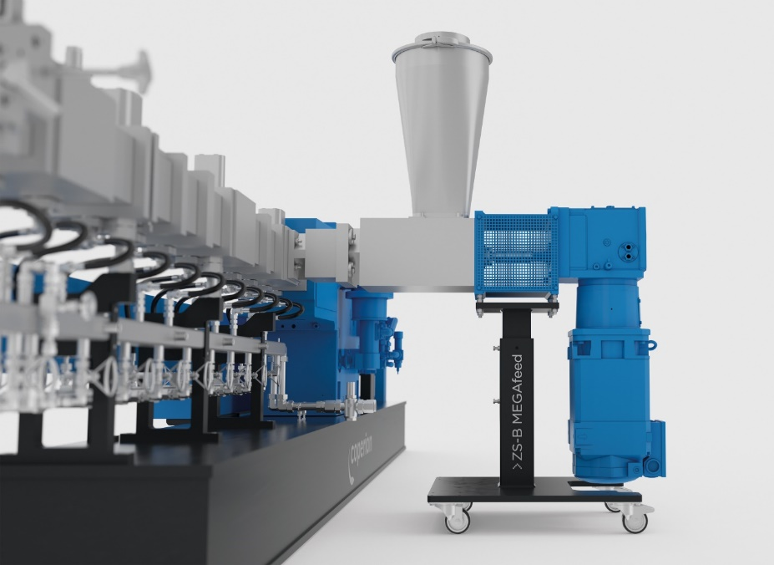
Thanks to its high intake potential, the recycling of plastic fiber and flake using the ZS-B MEGAfeed side feeder from Coperion becomes much more economical or even possible in the first place.
Photo: Coperion, Stuttgart, Germany

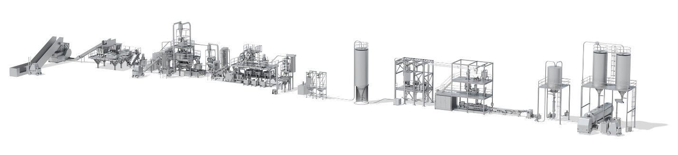

With complete systems for plastics recycling from a single source, Coperion and Herbold are setting new standards for the industry.
Photo: Coperion, Stuttgart, Germany
The HV 70 plastcompactor is the most powerful of the series from Herbold Meckesheim. It processes the feedstock in continuous operation between a rotating and a fixed compactor disk, which are equipped with screwed-on and easily exchangeable kneading bars.
Photo: Herbold Meckesheim, Meckesheim, Germany

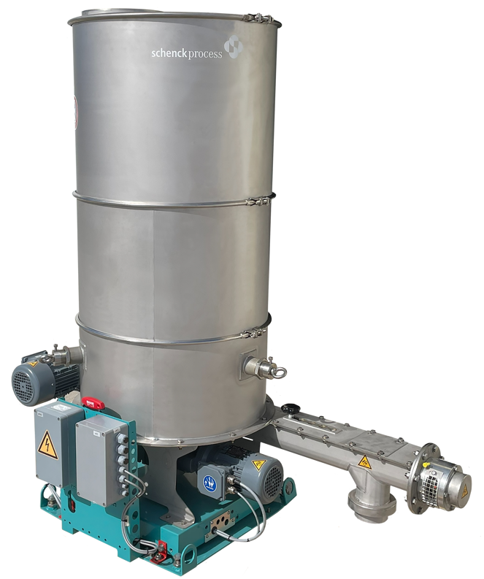
The Schenck Process FPM MechaTron® Flat Bottom (FB) feeder is ideal for feeding low bulk density materials such as chopped films and scrap.
Image: Schenck Process FPM, Whitewater, WI

