Contact
Julia Conrad
Marketing Communications
Coperion GmbH
Theodorstrasse 10
70469 Stuttgart/Germany

Phone +49 (0)711 897 22 27
Fax +49 (0)711 897 39 74
Julia.Conrad@coperion.com
www.coperion.com

Press release

Coperion at wire 2024

Flexible Solutions for Efficient Cable Compounds Production

Stuttgart, Germany, April 2024 – At wire 2024 (April 15-19, 2024, Düsseldorf/Germany) Coperion will present flexible solutions for the efficient production of high-quality compounds for a wide variety of cable applications at booth 13A44 in hall 13. Coperion’s extrusion technology, such as the ZSK twin screw extruder and the KP Kombiplast Compounder, has proven ideal for producing a broad variety of cable compounds for different applications, for example HFFR, XLPE Silan cross-linkable PE or PVC. Coperion also offers trusted solutions for the manufacturing of high-voltage cable compounds. Together with Coperion K-Tron feeders for high accuracy feeding of all ingredients as well as gentle conveying and material handling technology, manufacturers benefit from integrated turnkey solutions from one source.
ZSK Extruder as Suitable Solution for Single-Stage Cable Compounding
The high performance ZSK twin screw extruder represents a flexible and economical system for the production of different cable compounds. High throughput rates, gentle product handling for a high quality of the end products and high energy efficiency thanks to its low specific energy requirement are only three advantages of this extruder series. In addition, the modular design of the process section allows for individual configuration for the varying requirements of different types of cables such as semiconductive carbon black compounds, XLPE, HFFR, Silan cross-linkable PE, fluoropolymers and TPE. Beside the process section all peripheral equipment can be adjusted according to the process needs. This gives manufacturers the flexibility they need for an efficient and reliable process.
Homogeneity of the cable compounds is key when producing high quality products. The ZSK extruder is ideally suited for this task as the good mixing properties effectively avoid agglomerations. This ensures excellent dispersion of even hard to handle ingredients. Together with the high accuracy Coperion K-Tron feeders and reliable peripheral equipment Coperion offers a complete system that gives manufacturers the possibility to produce high quality cables with the appropriate characteristics in terms of durability, heat or wear resistance at a good price/performance ratio.
Efficient Two-Stage Compounding Process for PVC Cables with the KP Kombiplast Compounder
With the Kombiplast KP Two-Stage Compounder and the Eccentric Pelletizer EGR Coperion offers an economical and reliable compounding and pelletizing solution. The Kombiplast KP combines a ZSK twin screw extruder with a single-screw discharge screw ES-A for gentle pressure build-up of shear-sensitive products. The EGR eccentric pelletizer is seamlessly connected to the ES-A and ensures an even material flow through the die plate. The optimized design allows an easy integration of a screen changer and an efficient pellet transport. Thanks to the EGR’s optimized knife rotor the dust content of PVC pellets can be effectively minimized. The system set-up is characterized by very gentle operation and short residence time for highest product quality. High flexibility in terms of product changes and machine modifications make the system particularly versatile.
“Coperion is a long-standing partner of cable manufacturers and provides with the Coperion technology an ideal and flexible solution for different requirements and a variety of cable compounds. Manufacturers benefit from long-term experience, comprehensive process know-how and a technology that achieves the highest product quality and maximum economic efficiency”, so Matthias Link, Business Segment Manager, PVC & Cable compounds at Coperion.

About Coperion
Coperion (www.coperion.com) is a global industrial and technological company in the areas of compounding and extrusion machinery, sorting, shredding and washing equipment, feeding systems, bulk material handling and services. Coperion develops, produces, and services plants, machinery, and components for the plastics and plastics recycling industry as well as for the chemical, food, pharmaceutical, and minerals industries. Coperion employs over 5,000 people worldwide in its three business areas: Polymer, Food Health & Nutrition, and Aftermarket Sales and Service, as well as in its 50 sales and service companies. Coperion is a subsidiary company of Hillenbrand (NYSE: HI), a global industrial corporation offering highly developed processing machinery and solutions that are relevant to processes for customers in a variety of industries around the world. www.hillenbrand.com

Dear Colleagues,
You can find and download this press release in German and English and print-ready color images at
https://www.coperion.com/en/news-media/newsroom/

.
Editor contact and copies:
Dr. Jörg Wolters, KONSENS Public Relations GmbH & Co. KG,
Hans-Böckler-Str. 20, D - 63811 Stockstadt am Main, GERMANY
Tel.: +49 (0)60 27/ 99 00 5--0
E-Mail: mail@konsens.de, Internet: www.konsens.de
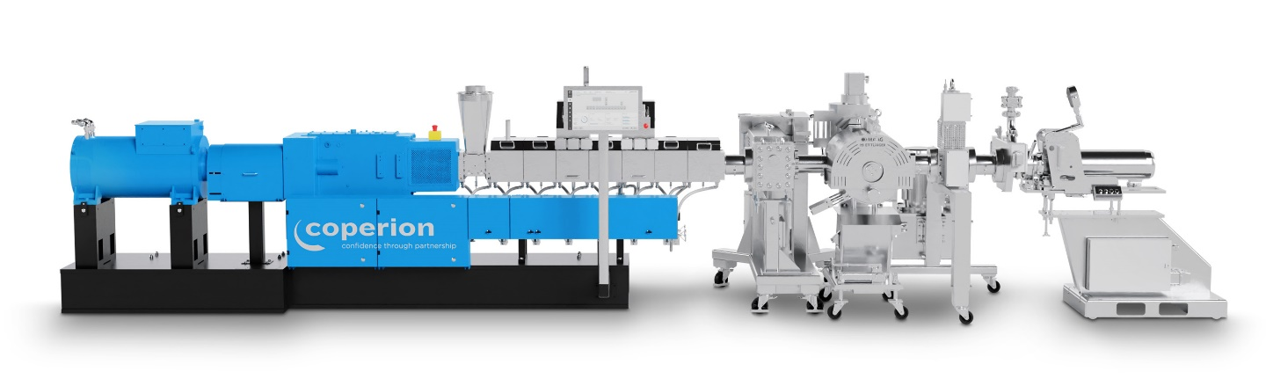

With the ZSK technology Coperion offers an ideal and flexible solution for different requirements and a variety of cable compounds.
Photo: Coperion, Stuttgart, Germany

