**Contact**

Shari Lake

Director of Marketing

Coperion K-Tron Salina, Inc.

606 North Front Street

Salina, KS 67401, USA

Telephone: +1 (785) 825-3884

slake@coperionktron.com

www.coperion.com www.coperionktron.com

Press Release

**Coperion K-Tron at Fakuma 2014**

**Gentle feeding of free-flowing pellets, granules and friable bulk materials**

*Stuttgart, August 2014* – Coperion K-Tron, Niederlenz, Switzerland, presents a BSP-135 Bulk Solids Pump feeder on a pivoting base as well as a Gravimetric Batch Blender with integrated Vacuum Receivers and Powder Feeder on its booth A6-6406 in hall 6 at this year’s Fakuma. The patented Coperion K-Tron Bulk Solids Pump (BSP) feeder line has been specifically designed and engineered to provide gentle, precise feeding of free-flowing pellets, granules, and friable bulk materials. BSP feeders do not use the usual screws/augers, belts or vibratory trays to convey the material. They utilize positive displacement action to feed free flowing materials with highest accuracy, offering uniform discharge, consistent volume and gentle handling. The BSP feeders have vertical rotating discs that create feeding ducts. Material moves smoothly from storage hopper to discharge outlet through a “product lock-up zone,” achieving true linear mass flow. With only one moving part, these compact feeders are cleaned in seconds, making them ideal for applications with frequent material changes.

**Gravimetric Batch Blender with integrated Vacuum Receivers and Powder Feeder**

Gravimetric Batch Blenders of Coperion K-Tron are available in various sizes from 0.5 to 25 kg total batch size and include up to eight main feed elements depending on the unit. Each unit is designed with an integrated loading platform for mounting material loaders or vacuum receivers. The blenders include an advanced metering and weighing system that accurately controls all ingredients of every batch to the desired amounts and is not averaged over multiple batches. Coperion K-Tron blenders are compact with a robust design. They are designed and constructed of heavy gauge steel to withstand the most rigorous of operating conditions. The load cell is overload protected and guarded from physical damage. All blenders include self-optimizing software for the most efficient output on every recipe. Due to the continuous mixing of the bulk materials mixing times do not need to be adjusted and the consistency of every mix is ensured.

The Gravimetric Batch Blender which is on display at Coperion K-Tron’s Fakuma booth is equipped with two integrated Vacuum Receivers. The Series 2400 Vacuum Receivers are designed to high quality standards for pneumatically conveying powders, pellets, granular and recycling materials. Due to the modular design of the receivers, the material of construction, power, filtration and receiver inlet sections can be individually adjusted to meet current application requirements and future needs. Six models in several designs cover conveying rates from 330 to 6,800 kg/hr [720 to 15,000 lb/hr]. Materials of construction include aluminum, carbon and stainless steel.

Besides the Vacuum Receivers the Gravimetric Batch Blender is equipped with a Powder Feeder.Twin Screw Powder Feeders are designed to optimally handle difficult materials such as pigments, sticky, bridging or flooding powders, fibers and fiberglass. Coperion K-Tron's twin screw volumetric feeders are available in different sizes and a range of models cover feed rates from 0.01 dm³/hr to 1,600 dm³/hr [0.0004 ft3/hr to 45,300 ft3/hr]. Depending on the configuration the feeders are optimized for different requirements – for fast material changes, for easy clean up or to satisfy high sanitary needs.

Coperion ([www.coperion.com](http://www.coperion.com)) is the international market and technology leader in compounding systems, feeding technology, bulk materials handling systems and services. Coperion designs, develops, manufactures and maintains systems, machines and components for the plastics, chemicals, pharmaceutical, food and minerals industries. Within its four divisions – Compounding & Extrusion, Equipment & Systems, Materials Handling and Service – Coperion has 2,500 employees and nearly 40 sales and service companies worldwide.

Coperion K-Tron ([www.coperionktron.com](http://www.coperionktron.com)) is a brand of Coperion.



Dear Colleagues,   
This press release in German, English and the colour photos in printable quality are available for download from  
[**http://www.coperion.com/en/news/newsroom/**](http://www.coperion.com/en/news/newsroom/)

Editorial contact and voucher copies:

Dr. Georg Krassowski, KONSENS Public Relations GmbH & Co. KG,  
Hans-Kudlich-Straße 25, D-64823 Groß-Umstadt  
Tel.:+49 (0)60 78/93 63-0, Fax: +49 (0)60 78/93 63-20  
E-Mail: mail@konsens.de, Internet: [www.konsens.de](http://www.konsens.de)

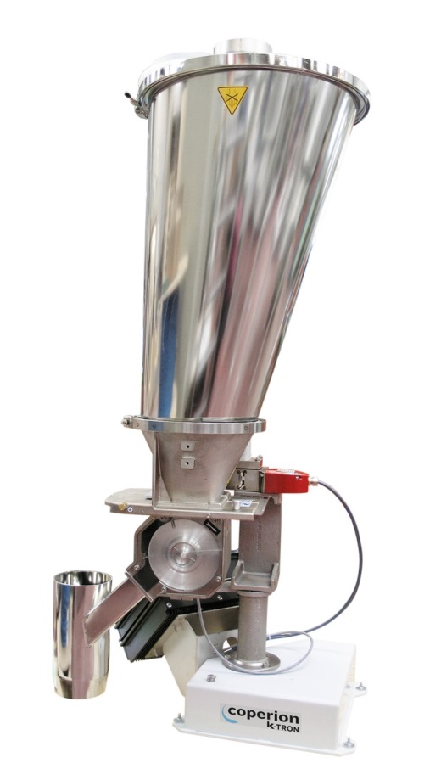

*The patented Coperion K-Tron Bulk Solids Pump (BSP) feeder line has been specifically designed and engineered to provide gentle, precise feeding of free-flowing pellets, granules and friable bulk materials.*

*Image: Coperion K-Tron, Niederlenz/Switzerland*

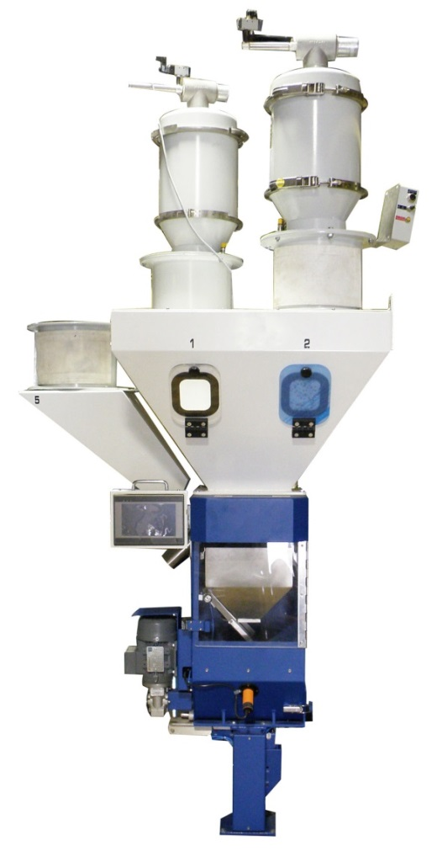

*Because of their compact and robust design, Coperion K-Tron’s Gravimetric Batch Blenders are protected against vibrations and shocks.*

*Image: Coperion K-Tron, Niederlenz/ Switzerland*