Contact
Andrea Trautmann
Marketing Communications
Materials Handling
Coperion GmbH
Niederbieger Strasse 9
88250 Weingarten / Germany

Phone: +49 (0)751 408 578
Fax: +49 (0)751 408 99 578
andrea.trautmann@coperion.com
www.coperion.com

Press Release

Coperion Hygienic PLUS rotary valves – the first rotary valves in the world that are certified by EHEDG for dry cleaning

Weingarten, April 2014 – With the range of discharge valves type ZRD and blow-through valves type ZXD, Coperion GmbH now offers the food industry the first rotary valves in the world in Hygienic PLUS execution to be certified in compliance with the criteria of the European Hygienic Engineering & Design Group (EHEDG), type ED. These criteria formulate the requirements to be met by components that are used in systems with dry operation and dry cleaning processes. Important features of the certified Hygienic PLUS rotary valves are that they are easy to dismantle and that the component areas can be easily accessed for cleaning and inspection. The surfaces are smooth and the interfaces to the areas in contact with the product are step-free. Coperion was already a pioneer years ago in the development of CIP-compliant (Cleaning in Place), certified rotary valves and diverter valves that are cleaned with liquids. With the new EHEDG type ED-certified rotary valves the company now also supplies dry cleaning components to assist system integrators and endusers who must reliably satisfy high requirements when it comes to sanitary design and operational safety in the food industry during the production, processing and transport of powders and pellets. The ZRD and ZXD Hygienic PLUS rotary valves are used in pneumatic conveying systems and for the discharge of powdered and pelletized materials.

Experience has shown that in consistently dry operation processes the growth of micro-organisms resulting from residual moisture and product residues after a wet cleaning of systems can be prevented. However, not all components are equally suitable for use in dry processes. The requirements laid out by the EHEDG can be of assistance in the assessment of their suitability. According to these specifications, the Coperion ED-certified rotary valve types ZXD (blow-through valve) and ZRD (discharge valve) in Hygienic PLUS execution satisfy all requirements for dry cleaning. In addition to standard step-free connections, polished surfaces that are in contact with the product with an average peak-to-valley height of ≤ 0.8µm and FDA compliant seals, both types are available with additional options. For example, the track-proven FXS (Full Access System) swing-out system provides free access to the interior of the rotary valve. The also optional sealing cassette for the shaft seal in the side plate can be easily pulled out with a convenient tool and dismantled into its individual parts. Both valve types not only meet the requirements of the regulation (EC) no. 1935/2004 (requirements to be met by materials and objects that are destined to come into contact with food) but are also available as versions that are suitable for use in potentially explosive areas (ATEX zones).

The European Hygienic Engineering & Design Group is a group of experts from the machine and component sector, specialists from the food industry as well as from research institutes and health authorities. The organisation was founded in 1989 with the aim of promoting awareness of hygiene during food processing and packaging. The main task of the EHEDG is to contribute to the hygienic design and construction in all fields of food production and therefore ensure safe food manufacturing (www.ehedg.org).

Coperion (www.coperion.com) is the international market and technology leader in compounding systems, feeding technology, bulk materials handling systems and services. Coperion designs, develops, manufactures and maintains systems, machines and components for the plastics, chemicals, pharmaceutical, food and minerals industries. Within its four divisions – Compounding Machines, Materials Handling/Extrusion Systems, Coperion K-Tron/Food and Service – Coperion has 2,500 employees and nearly 40 sales and service companies worldwide.


Dear Colleagues,
This press release in German and English
as well as the images in printable quality are available for download from
http://www.coperion.com/en/news/newsroom/
.

Editorial contact and specimen copies:
Dr. Georg Krassowski, Konsens Public Relations GmbH & Co. KG,
Hans-Kudlich-Strasse 25, D-64823 Gross-Umstadt
Tel.:+49 (0)60 78/93 63-0, Fax: +49 (0)60 78/93 63-20
E-mail: mail@konsens.de, Internet: www.konsens.de

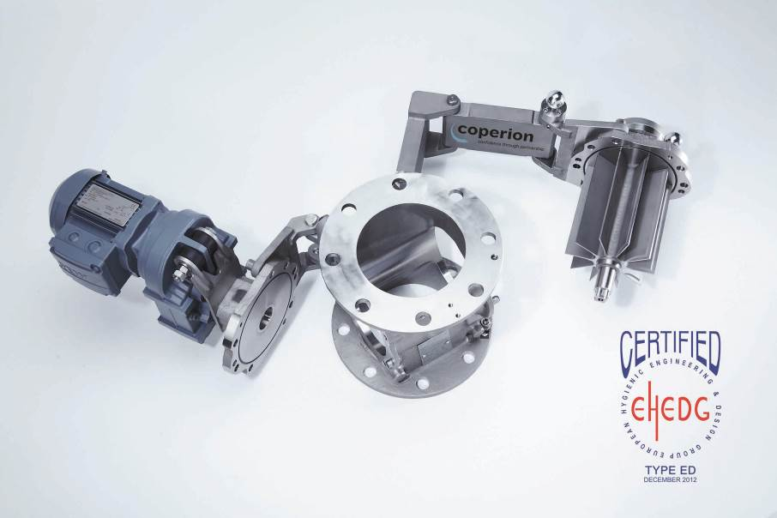
Coperion discharge valves type ZRD Hygienic PLUS and the blow-through valves type ZXD Hygienic PLUS are now also available as EHEDG type ED certified rotary valves for dry cleaning. The FXS (Full Access System) swing-out system permits free access to the interior of the rotary valves for easy and efficient cleaning.
Image: Coperion, Weingarten

