Contact
Shari Lake
Director of Marketing
Coperion K-Tron Salina, Inc.
606 North Front Street
Salina, KS 67401 USA

Telephone +1 (785) 825-3884
slake@coperionktron.com
www.coperion.com

Press Release

Innovative Technology for Food Ingredient Extrusion, Feeding and Pneumatic Conveying

Coperion and Coperion K-Tron to Exhibit at IFT 2017
Sewell, NJ, USA (June 2017) – At this year’s IFT Tech 2017, Sands Expo & Convention Center, Las Vegas, NV, USA in Booth 1793 Coperion and Coperion K-Tron present the latest innovations and technologies for the food and pet food industry. The company invites you to stop by their booth and learn about extrusion for product development including flavor encapsulation, wet and dry texturized proteins and specialty end product shapes and sizes, as well as feeding and material handling technology, batching and dispensing of the most difficult flowing ingredients and the most technologically advanced components in the food industry. Exhibits on display include a gravimetric quick change feeder and video demonstrating Coperion and Coperion K-Tron’s food process solutions.

Stop by and visit with our experts on the ZSK Mv PLUS Twin Screw Food Extruder – The ideal extrusion system for many types of food and pet food
Coperion’s twin screw extruder ZSK Mv PLUS provides ideal conditions for the extrusion of many types of food and pet food products. The process section of the ZSK twin screw extruder consists of several barrels in which the co-rotating screws operate. The closely intermeshing screws with their tight self-wiping profile eliminate stagnant zones over the whole length of the process section. The effect of this is a constantly high conveying efficiency and perfect self-cleaning.

The modular design of the ZSK Mv PLUS and its unusual combination of free screw volume, screw speed and torque enable this twin screw extruder series to be individually configured for every application. The complete portfolio includes a wide range of sizes, allowing customers to process any required throughput range from laboratory to production scale.

Quick Change Feeder – For handling large variety of products and a simple means of preventing contamination – Model K2-ML-QC screw feeder with two interchangeable quick change modules on a D5 platform scale
Coperion K-Tron’s T35/S60 Quick Change Feeder is specially designed for applications requiring the maximum possible material handling and changeover flexibility along with the convenience of easy cleaning capability. It enables a fast exchange of the feeding module which minimizes downtime and eliminates the risk of cross-contamination. The QC-Feeder is available in economical volumetric or high-performance loss-in-weight configurations.

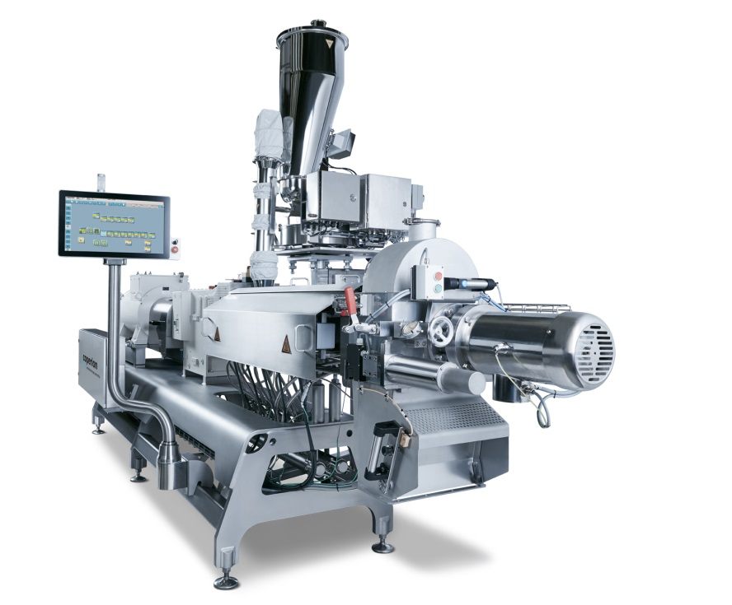
ZSK Mv PLUS Twin screw food extruder
Image: Coperion, Stuttgart, Germany

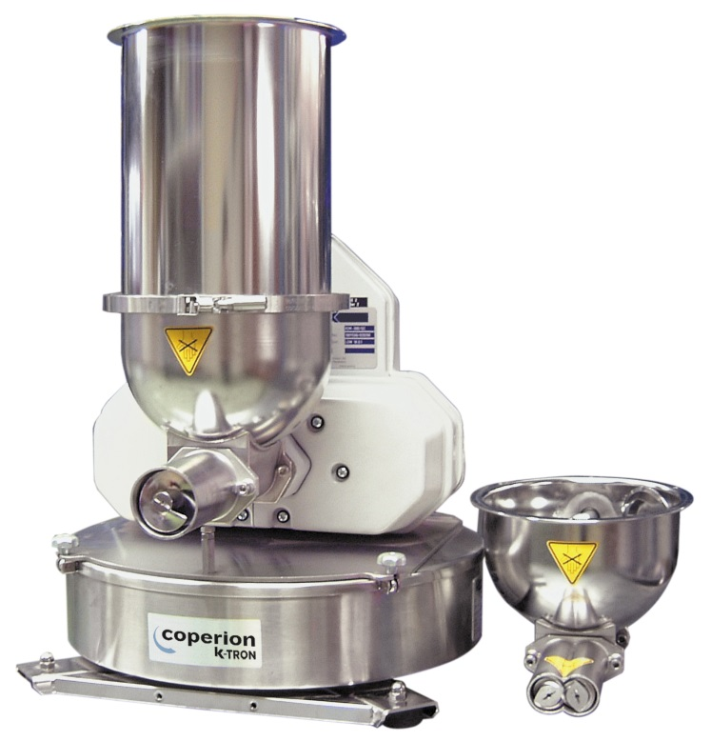
K2-ML-QC screw feeder on a D5 platform scale
Image: Coperion K-Tron, Sewell, NJ, USA

For more information visit www.coperion.com/food
Coperion is the international market and technology leader in compounding and extrusion systems, feeding and weighing technology, bulk materials handling systems and services. Coperion designs, develops, manufactures and maintains systems, machines and components for the plastics, chemicals, pharmaceutical, food and minerals industries. Within its four divisions – Compounding & Extrusion, Equipment & Systems, Materials Handling and Service – Coperion has 2,500 employees and nearly 30 sales and service companies worldwide. Coperion K-Tron is part of the Equipment & Systems division of Coperion. For more information visit www.coperion.com or email info@coperion.com.

Dear Colleagues,
an MS-WORD file of this press release in English and
a printable-grade copy of the enclosed image are available for download at
https://www.coperion.com/en/news-media/newsroom/

Editorial contact and voucher copies:
Dr. Jörg Wolters, KONSENS Public Relations GmbH & Co. KG,
Hans-Kudlich-Straße 25, D-64823 Groß-Umstadt
Phone: +49 (0)60 78/93 63-0, Fax: +49 (0)60 78/93 63-20
E-Mail: mail@konsens.de, Internet: www.konsens.de



