Contact
Andrea Trautmann
Marketing Communications
Coperion GmbH
Niederbieger Strasse 9
88250 Weingarten / Germany

Telefone +49 (0)751 408 578
Telefax +49 (0)751 408 200
andrea.trautmann@coperion.com
www.coperion.com
Hall 4 / 4-290
Press release

RotorCheck 5.0 improves safety and convenience when operating rotary valves

Weingarten, Germany, August 2017 – Coperion will be presenting Version 5.0 of its proven RotorCheck contact monitoring system for rotary valves at booth 4-290 in hall 4 at Powtech 2017, which is taking place in Nuremberg from September 26 to 28, 2017. In production and processing operations, this system registers, evaluates and reports unwanted contact between the rotor and housing in order to be able to prevent metallic abrasion and thus potential contamination of the product being conveyed. Industrial sectors with high quality requirements, frequently changing products and recipes or a high number of cleaning cycles stand to benefit from this in particular. The newly introduced physical separation of measured value logging and evaluation electronics has advantages in terms of operation and maintenance, while the redeveloped control system provides advanced options for event diagnosis and connection to host systems. Furthermore, the use of extremely high-quality components contributes to longer uninterrupted running times.

Low space requirement, high ease of maintenance
The monitoring principle of the RotorCheck remains unchanged: An electrically conductive connection is created as soon as the housing and rotor come into contact. This is then registered by the control system. In the process, the software filters out coincidental measurement signal fluctuations – such as those caused by the product – and reports potentially dangerous faults to the customer’s control center.
While the signal detection itself takes place in the valve, for the first time Version 5.0 allows for the snap-in installation of the control system housing in the control cabinet. The physical separation reduces the amount of space required on the valve while simultaneously simplifying the operation and maintenance of valves with an extraction device. This is particularly advantageous in production environments where dirt, dust, heat, vibrations, moisture or electromagnetic waves may occur. What’s more, the control system is now also accessible even when it is impossible to enter the production area itself for safety reasons, e.g. while CIP cleaning is underway. RotorCheck 5.0 is suitable for deployment in Ex zones in combination with optional Zener barriers.

Longer uninterrupted operation and increased functionality
Extremely high-quality components are used in the latest generation of RotorCheck products for maximum reliability and ease of maintenance. Hybrid bearings with ceramic roller elements optimize electrical insulation between the rotor and the housing, to name just one example. At the same time, these are considerably more robust than conventional solutions with regard to installation and maintenance. The slip-ring rotor is designed for a service life of around five years and thus only requires around one tenth of the maintenance effort of comparable conventional products with a biannual replacement interval. Thanks to the new lower number of individual parts, Version 5.0 is easier to install and calibrate, which reduces the effort required for quick cleaning in particular.
The electronic functions of the RotorCheck 5.0 are also considerably more comprehensive than in the previous version. Consequently, an optional field bus interface that significantly reduces installation effort is now available to the user alongside analog and digital inputs/outputs. Moreover, the new control system facilitates flexible adaptation of the device’s parameters to changing production conditions and cleaning cycles. The measurement signal is now available in graphic format via web interface, which makes diagnosis more convenient. And due to the fact that the operating data is cached in the control system, faults can be reproduced and analyzed at a later time. In addition, LEDs on the RotorCheck housing now visually indicate the presence of anomalies with improved clarity.
New and existing rotary valves alike can be equipped with the extended features of the optimized RotorCheck 5.0, making them ideally prepared for the increasing complexity and degree of automation in modern industrial plants.

Coperion is the international market and technology leader in compounding and extrusion systems, feeding and weighing technology, bulk materials handling systems and services. Coperion designs, develops, manufactures and maintains systems, machines and components for the plastics, chemicals, pharmaceutical, food and minerals industries. Within its four divisions – Compounding & Extrusion, Equipment & Systems, Materials Handling and Service – Coperion has 2,500 employees and nearly 30 sales and service companies worldwide. For more information visit www.coperion.com or email info@coperion.com.



Dear colleagues,
You can download this press release in German and English and the colour photos in printable quality from the Internet at https://www.coperion.com/en/news-media/newsroom/

Editorial contact and voucher copies:
Dr. Jörg Wolters, KONSENS Public Relations GmbH & Co. KG,
Hans-Kudlich-Strasse 25, D-64823 Groß-Umstadt
Phone: +49 (0)60 78/93 63-0, Fax: +49 (0)60 78/93 63-20
E-Mail: mail@konsens.de, Internet: www.konsens.de

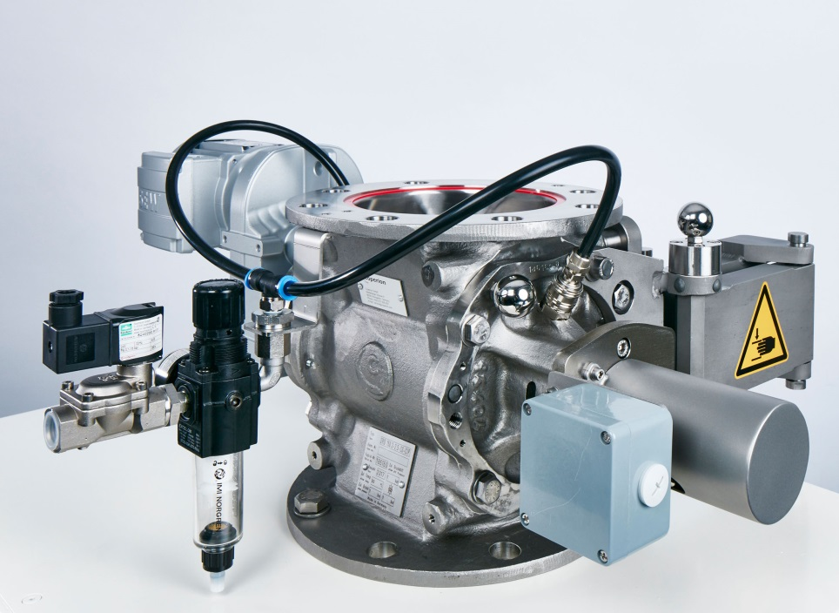

ZRD 150 rotary valve with RotorCheck
Image: Coperion, Weingarten, Germany

