Contact
Petfood Forum 2019
Booth 1143
Shari Lake
Director of Marketing
Coperion K-Tron Salina, Inc.
606 North Front Street
Salina, KS 67401 USA

Shari.lake@coperion.com
Telephone +1 (785) 825-3884
www.coperion.com

Press Release

Coperion K-Tron Displays Feeding and Conveying Demonstration Tailored to the Pet Food Industry

Sewell, NJ, USA (April 2019) Coperion and Coperion K-Tron formally announce exhibition in Booth 1143 at Petfood Forum 2019 (April 30-May 1, 2019) in Kansas City, Missouri.
The booth will feature a working recirculating conveying system focusing on the loss-in-weight feeding and refilling of ingredients to continuous processes, such as extruders and mixers. The complete assembly is mounted on a portable stand with a recycle loop of Semolina after it exits the feeder and is conveyed to a receiver for continuous refill. The Coperion K-Tron line of feeders provides for the highest degree of accuracy in ingredient and product delivery in order to optimize ingredient cost savings. The KT20 Twin Screw Feeder is displayed on a platform scale with the P10 Central Receiver and controller demonstrating a custom solution for difficult conveying applications. Integrated control system and customized PLC control allow for a variety of programming options including ingredient control and recipe management.

Coperion K-Tron Twin Screw Feeder for High Accuracy in Ingredient and Product Delivery
The Coperion K-Tron Twin Screw KT20 Feeder with interchangeable feeding tools is mounted on a fully enclosed platform scale for high accuracy feeding of difficult flowing ingredients including additives, probiotics and flavors. All feeder parts in contact with the material being fed are stainless steel, and feeding equipment is easy to disassemble. A horizontal agitator gently moves the bulk material to the large throat and then into the screws. The feeder can be used for both gravimetric feeding to continuous processes and loss-in-weight batching direct to batch blenders. Specialty designs are available for clustering of feeders above extruders, blenders and other processes for optimal accessibility and ease of cleaning.

Coperion K-Tron P-Series Receivers for Sanitary Solutions
Coperion K-Tron P-Series Receivers provide a sanitary solution for difficult material conveying applications in the food industry and meet 3A Dairy sanitary requirements. The sanitary design includes steep cone angles to ensure excellent discharge and band clamps for quick disassembly. The P-Series sanitary receivers can be used for gain-in-weight or loss-in-weight feeder refill applications, simple up and in systems or engineered for larger, central vacuum conveying systems. Typical materials include flakes, free-flowing to poorly flowing powders and materials requiring gentle conveying. The model on display is a P10.

Word count: 365

Coperion (www.coperion.comwww.coperion.com) is the international market and technology leader in compounding systems, feeding technology, bulk materials handling systems and services. Coperion designs, develops, manufactures and maintains systems, machines and components for the plastics, chemicals, pharmaceutical, food and minerals industries. Within its four divisions – Compounding & Extrusion, Equipment & Systems, Materials Handling and Service – Coperion has 2,500 employees and nearly 40 sales and service companies worldwide. For more information visit www.coperion.com or email info@coperion.com.

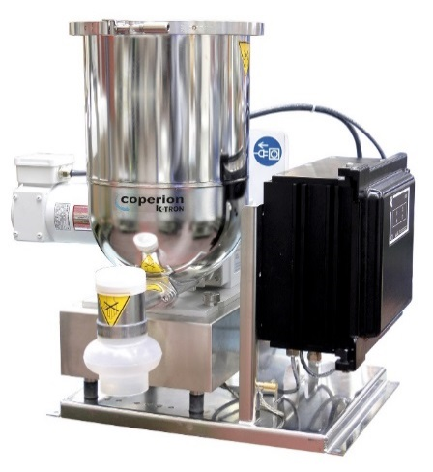
Coperion K-Tron Twin Screw feeding equipment is easy to dismantle.
Image: Coperion K-Tron, Sewell, NJ
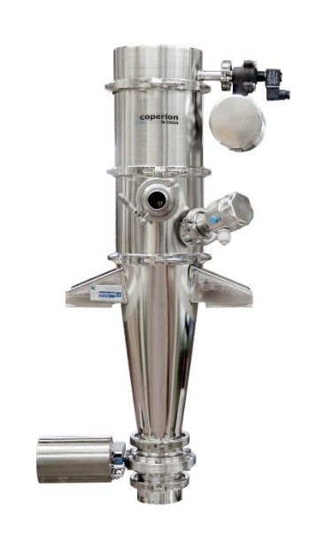
Coperion K-Tron P10 pneumatic conveying vacuum receiver is a perfect solution for sanitary ingredient handling.
Image: Coperion K-Tron, Salina, KS

