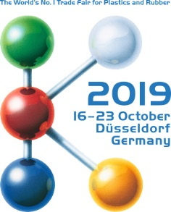 | Contact  Kathrin Fleuchaus  Marketing Communications  Coperion GmbH  Theodorstraße 10  70469 Stuttgart/Germany  Telephone +49 (0)711 897 25 07  Fax +49 (0)711 897 39 74  kathrin.fleuchaus@coperion.com  www.coperion.com
Coperion and eurotec® at K 2019
Coperion congratulates eurotec® on its 15th Anniversary
Düsseldorf, 17 October 2019 — Turkish compounder eurotec® is celebrating its 15th anniversary at K 2019. Representatives from Coperion used the opportunity to congratulate eurotec® on its success and to express Coperion’s gratitude for many years of successful cooperation between the two companies.
eurotec® produces engineering plastics for various industries, primarily in the automotive, electrical, electronic, and household device sectors. To manufacture its plastics, eurotec® has relied exclusively on Coperion’s high-torque ZSK twin screw extruders for many years.
“Coperion’s reliable, high-performance ZSK technology is an important foundation of our success in the market worldwide. With twin screw extruders from Coperion, we are able to manufacture engineering thermoplastics that are tailor made for our customers — constantly at the highest level of quality. Thanks to numerous thoroughly thought out features, the compounding machines are very easy to operate and make it possible to economically manufacture every size batch”, explained Murat Cansever of eurotec®.
Dr. Oliver Eitel, Engineering Plastics Business Segment Manager at Coperion in Stuttgart, added: “Over the last 15 years, eurotec® has succeeded in the market at developing itself into an established, valued, globally active manufacturer of engineering plastics. We congratulate eurotec© on its great success, and we’re proud to be able to support eurotec® with our ZSK extruders. We value our work with them that is based on mutual trust and we look forward to further projects together.”

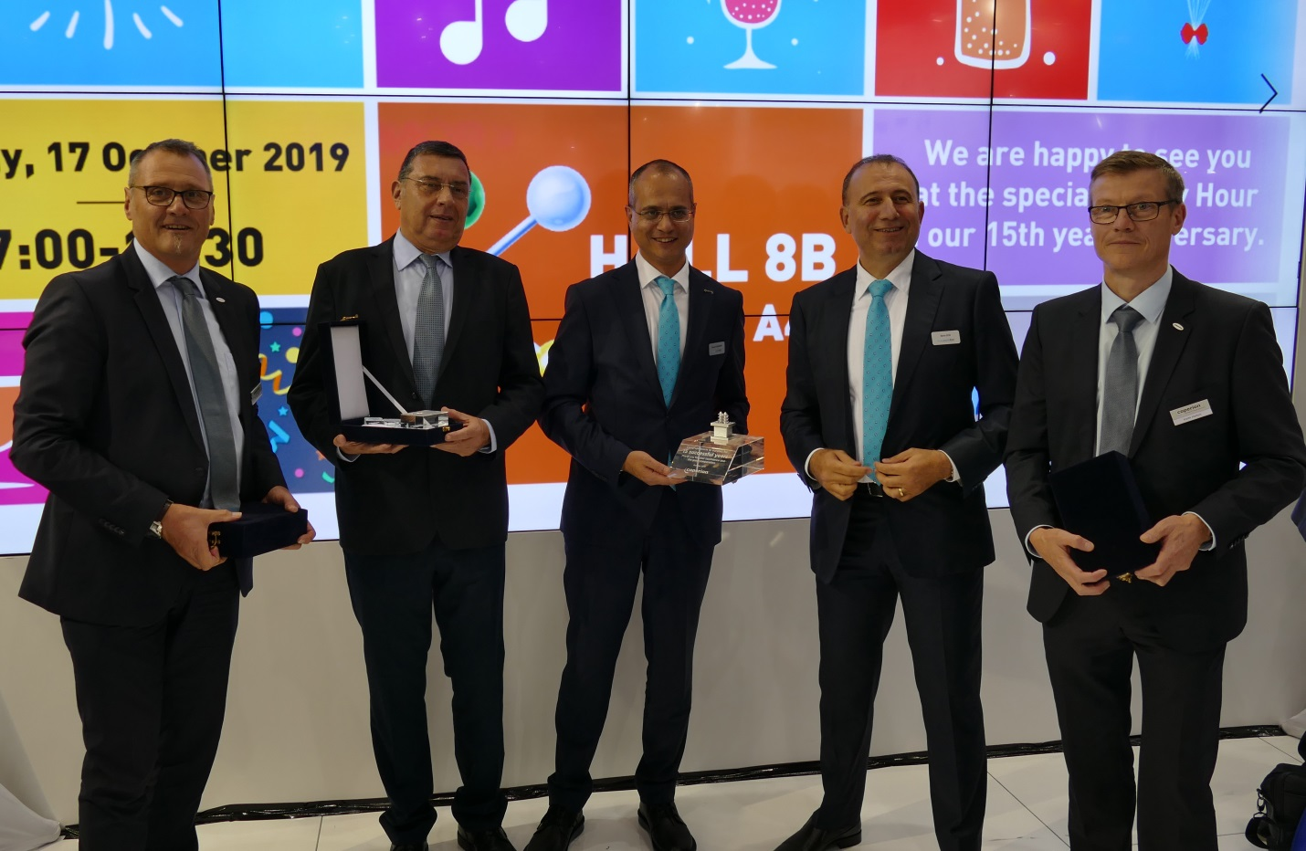

Representatives from Coperion used the opportunity to congratulate eurotec® on its success and to express Coperion’s gratitude for many years of successful cooperation between the two companies.

Coperion is the international market and technology leader in compounding and extrusion systems, feeding and weighing technology, bulk materials handling systems and services. Coperion designs, develops, manufactures and maintains systems, machines and components for the plastics, chemicals, pharmaceutical, food and minerals industries. Within its four divisions – Compounding & Extrusion, Equipment & Systems, Materials Handling and Service – Coperion has 2,500 employees and nearly 30 sales and service companies worldwide. Coperion K-Tron is part of the Equipment & Systems division of Coperion. For more information visit www.coperion.com or email info@coperion.com.



You can find and download this press release in German and English as well as print-ready color images at
https://www.coperion.com/en/news-media/newsroom/
.

