Contact
Bettina König
Marketing Communications
Coperion GmbH
Theodorstrasse 10
70469 Stuttgart, Germany

Phone +49 (0)711 897 22 15
Fax +49 (0)711 897 39 74
bettina.koenig@coperion.com
www.coperion.com

Press Release

Coperion and RenCom AB
Coperion supports RenCom in production of durable biomaterial
Stuttgart, July 2020 – Swedish innovation company RenCom AB has chosen Coperion’s state-of-the art twin screw extrusion system to enable the production of RENOL®, an innovative thermoplastic biomaterial that can be used to replace fossil-based plastics. Following comprehensive studies in Coperion’s extrusion test lab in Stuttgart, Germany, RenCom and Coperion were able to further develop the processing of this lignin-based material and transform it into durable, reusable biomaterial by using the ZSK twin screw extruder technology. RenCom will be able to produce up to 1,000 tons RENOL® per year starting late 2020.
Extrusion technology for future-oriented biomaterial
RenCom has a patented material and process that energy-efficiently transforms lignin into renewable, degradable biomaterial that can replace fossil plastics, marketed under the name RENOL®. Passing different process steps, including extrusion and compounding, RENOL® becomes a durable, reusable biomaterial that can be used for all kinds of plastic products, such as bags and glues. It can be used directly in existing production infrastructure without any modifications to machines or methods.
Coperion has in cooperation with RenCom designed a complete extrusion system comprising a ZSK co-rotating twin screw extruder, gravimetric feeders, a strand pelletizing system, a lignin bag dump station and a big bag station to RenCom. The ZSK Mv PLUS series unites an optimally balanced large free screw volume with high screw speeds and a high specific torque. Thanks to the deeply cut screw flights thermal stress on the raw material is very low and product processing is very gently. By using the side feeder ZS-B, fillers and additives can be added to the process section according to the requirements of the end product. The complete system will be delivered in October. High quality RENOL® pellets will be produced in the scale of 1,000 tons per year.

Partnership of two innovative companies
The comprehensive studies in Coperion’s test lab and the realization of the demo system for the production of RENOL® is seen as the beginning of a successful partnership between RenCom and Coperion.
Peter von Hoffmann, General Manager Business Unit Engineering Plastics & Special Applications at Coperion: “We are proud to supply extrusion process know-how and technology for such a future generation of biomaterial like RENOL®. We truly believe in RenCom’s green objectives and see great potential in their bioproduct RENOL®, which actively contributes to reducing CO₂ emissions in comparison to fossil-based plastics”
Christopher Carrick, RenCom’s Chief Executive Officer, adds: “We at RenCom are very happy to announce the partnership with Coperion. It is a fundamental key stone in our progress to supply our innovative material to a broad audience and to enter the market as early as beginning of 2021. Working with the best of its kind is particularly important as Coperion is the world leader in the field of extrusion and process engineering perfection. We are excited to further develop this partnership!”

About RenCom
RenCom is a Swedish innovation company that transform lignin, the most abundant unused biopolymer on earth, into a renewable and functional biomaterial called RENOL®. RenCom aims to supply the plastic industry with high performance granulates that will be converted into plastic bags, packaging materials, bottles, or injection molded pieces. The material has been tried out by several partners in the plastic field and the end products, containing RENOL®, will be on the market already year 2021. For more information visit www.lignin.se.

About Coperion
Coperion is the international market and technology leader in compounding and extrusion systems, feeding and weighing technology, bulk materials handling systems and services. Coperion designs, develops, manufactures and maintains systems, machines and components for the plastics, chemicals, pharmaceutical, food and minerals industries. Within its three divisions – Polymer, Equipment & Systems, and Service – Coperion has 2,500 employees and nearly 30 sales and service companies worldwide. For more information visit www.coperion.com or email info@coperion.com.


Dear colleagues,
You will find this press release in English and German together with the pictures in printable quality for download at
https://www.coperion.com/en/news-media/newsroom/
.

Editor contact and copies:
Dr. Jörg Wolters, KONSENS Public Relations GmbH & Co. KG,
Im Kühlen Grund 10, D-64823 Gross-Umstadt
Tel.: +49 (0)60 78/93 63-0, Fax: +49 (0)60 78/93 63-20
E-mail: mail@konsens.de, Internet: www.konsens.de

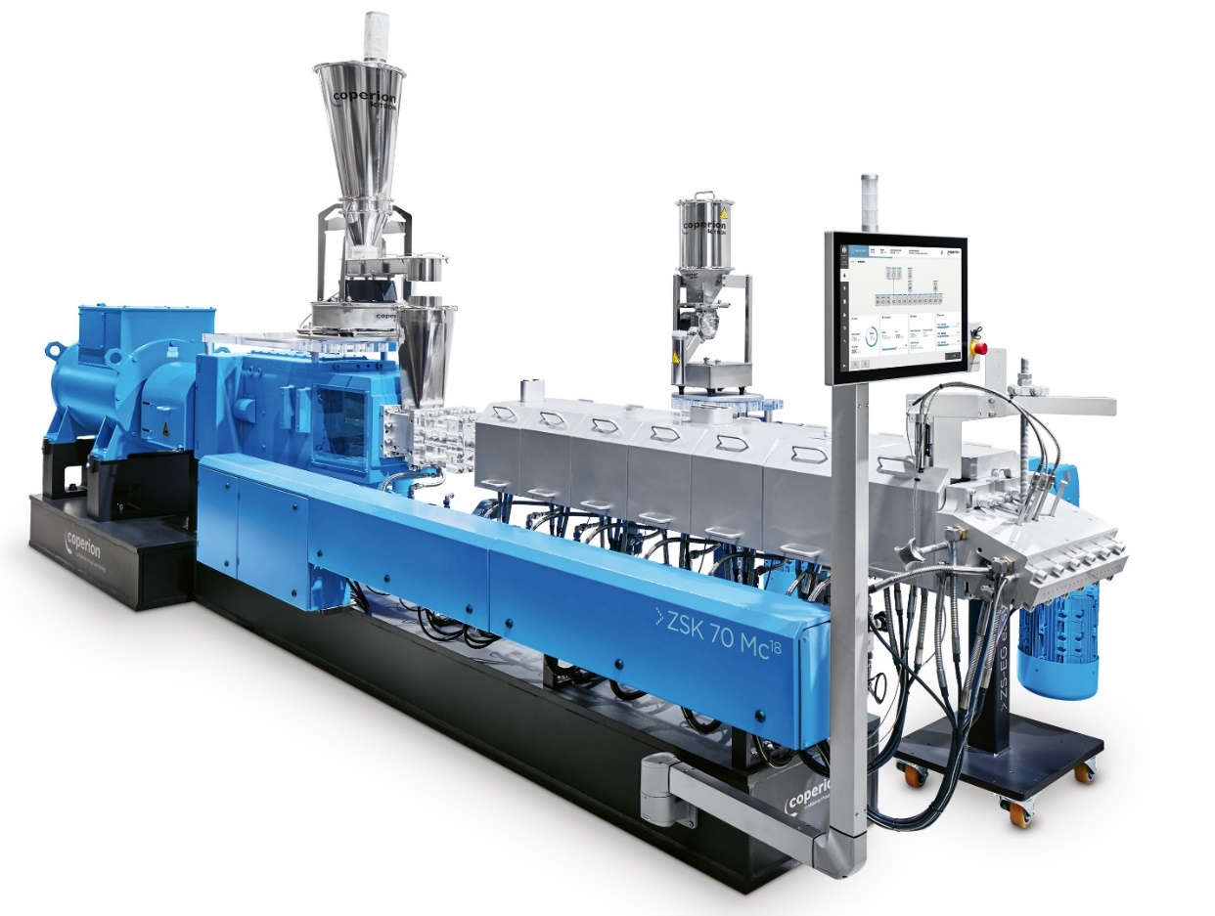
RenCom has chosen Coperion’s ZSK twin screw extrusion technology to enable the production of RENOL®.
Image: Coperion, Stuttgart
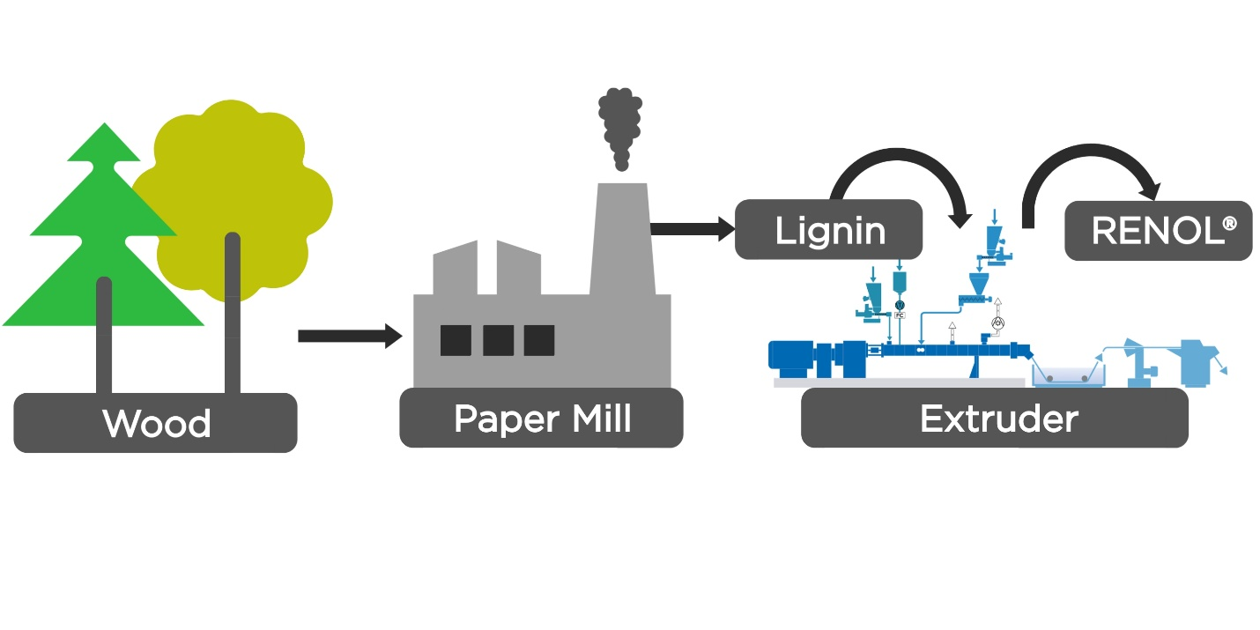
From wood to biodegradable thermoplastic biomaterial RENOL®
Image: Coperion, Stuttgart
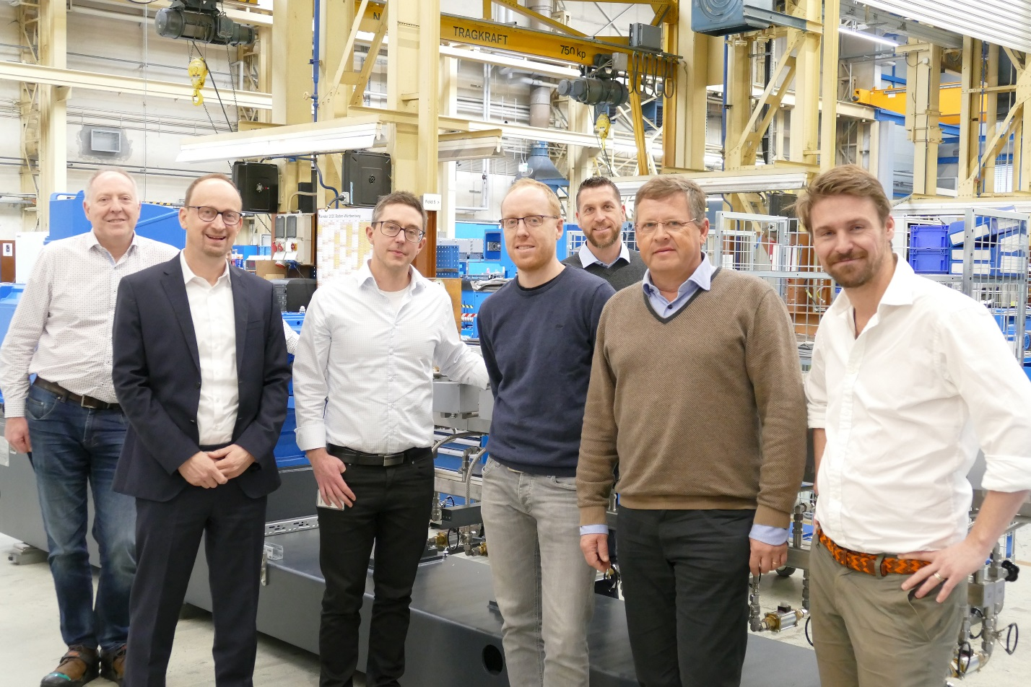
Coperion and RenCom team during project kick-off meeting in Stuttgart, Germany (from left to right: David Watmore, Peter von Hoffmann (both Coperion), Johan Verendel, RenCom, Stefan Hirsch, Levin Batschauer, Jörg Prochaska (all Coperion), Christopher Carrick (RenCom)
Image: Coperion, Stuttgart

