|  |  |
| --- | --- |
|  | **Contact**  Bettina König  Marketing Communications  Coperion GmbH  Theodorstraße 10  70469 Stuttgart/Germany  Telephone +49 (0)711 897 22 15  Fax +49 (0)711 897 39 74  bettina.koenig@coperion.com  www.coperion.com |

Press Release

**Coperion Service Solutions**

**Remote Commissioning and Modernization: Coperion’s Solution for Extruder Service in Challenging Times**

*Stuttgart, August 2020* — Coperion successfully achieved the complex modernization of a ZSK 250 high-capacity extruder completely utilizing remote processes and support. As this recent example shows, Coperion has successfully evolved its modernization efforts to utilize the Coperion ServiceBox, an integrated system for online monitoring and failure recording in extruders and compounders, as well as communication methods like video and telecommunication to complete customer requests. This ZSK 250 extruder modernization package encompassed both a control software update as well as mechanical overhauls on the system. A significant throughput increase was achieved on the extruder by modernizing the gearbox, mounting a new coupling, installing a ZS-EG side devolatilization and updating the EpcNT control, including a rebuild of the control cabinet and monitor. Coperion’s three member team, based in Stuttgart, Germany, worked directly with the customer to ensure proper software and mechanical updates. During this time when travel is limited by the pandemic, this achievement serves to show that Coperion is committed to the continued reliable rollout of its customer projects and hence their success.

**Blueprint For Further Projects**

Although Coperion has been utilizing the Coperion ServiceBox for many years to perform remote software updates on its extrusion systems, more complex mechanical remote tasks have been limited so far. With the successful modernization of this ZSK 250 high-capacity extruder, the proof of concept has been realized and a milestone has been set for complex maintenance and modernization projects utilizing remote service. Whether under the current pandemic condition or as customers fundamentally shift work expectations, Coperion offers a lean, flexible solution for machine commissioning and modernization of its extruders.

Stefan Lachenmayer, Head of Coperion’s Extruder Modernization team, is very confident in the future potential. “Through partnership and planning with our customers we can successfully execute complex remote projects. This recent success proves as another milestone in Coperion’s ability to evolve to meet current market requirements and successfully coordinate both mechanical and software modernization tasks utilizing the latest communication technology. We, as Coperion, are committed to supporting our customers via remote commissioning and modernization for both for large-scale extruders as well as refurbishing projects of any size.”

**About Coperion**

Coperion is the international market and technology leader in compounding and extrusion systems, feeding and weighing technology, bulk materials handling systems and services. Coperion designs, develops, manufactures and maintains systems, machines and components for the plastics, chemicals, pharmaceutical, food and minerals industries. Within its three divisions – Polymer, Equipment & Systems, and Service – Coperion has 2,500 employees and nearly 30 sales and service companies worldwide. For more information visit [www.coperion.com](http://www.coperion.com) or email [info@coperion.com](mailto:info@coperion.com).



Dear Colleagues,  
You can find and download this press release in German and English and print-ready color images at

**https://www.coperion.com/en/news-media/newsroom/**

.

Editorial contact and copies:

Dr. Jörg Wolters, KONSENS Public Relations GmbH & Co. KG,  
Im Kühlen Grund 10, D-64823 Groß-Umstadt  
Tel.:+49 (0)60 78/93 63-0, Fax: +49 (0)60 78/93 63-20  
E-Mail: mail@konsens.de, Internet: [www.konsens.de](http://www.konsens.de)

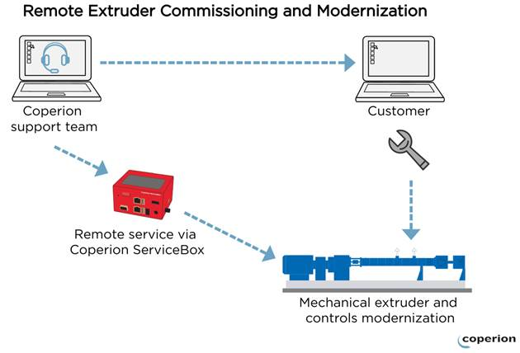

Coperion successfully achieved the complex modernization of a ZSK 250 high-capacity extruder completely utilizing remote processes and support.

*Image: Coperion GmbH, Stuttgart, Germany*