Contact
Kathrin Fleuchaus
Marketing Communications
Coperion GmbH
Theodorstrasse 10
70469 Stuttgart, Germany

Phone +49 (0)711 897 25 07
kathrin.fleuchaus@coperion.com
www.coperion.com

Press Release

Innovative Process for Bottle-to-Bottle Recycling
New Bottles From Old Bottles: Economical and FDA-Compliant Recycling of PET Flakes
Stuttgart, July 2021 – Polyethylene terephthalate (PET) is a high-value material that is on course to take over a key function in the plastics industry’s path toward a circular economy. PET flakes can now be processed without pre-drying into pellets using Coperion ZSK twin screw extruders. Next they are condensed in the SSP (Solid State Polycondensation) reactor, and reprocessed back into bottles again with the quality of virgin material.
PET recyclate manufactured using this innovative process has received approval from the United States Food and Drug Administration (FDA) for food-contact uses. Thanks to the highly efficient plastification within the ZSK extruder, Coperion systems for this bottle-to-bottle recycling process achieve throughput rates between 2 and 8 tons per hour, therefore recycling companies profit from very high product quality, reduced operating and logistic expenses as well as from energy cost savings up to 30% in comparison to conventional PET recycling methods.
Bottle-to-Bottle Recycling Now Clearly More Efficient
PET plays an ever more important role in recycling, due to the large volume of packaging materials in use today. PET is a very high-value material, possessing extremely good properties for reprocessing. Its continuously expanding use in single- and reusable bottles, as well as its recovery via deposit systems, add to its value. Correspondingly, it can be lucrative for companies to focus on PET recycling.
Before PET can be reprocessed, it must first be shredded to flakes and then cleaned. Ordinary technologies require pre-drying, crystallization or agglomeration of the PET flakes following washing. However, using the specialized technology from Coperion, the shredded PET can be fed directly into the ZSK twin screw extruder and compounded.
The shredded flakes are reliably fed into the ZSK extruder using high-accuracy SWB (Smart Weigh Belt) feeders or gravimetric feeders from Coperion K-Tron. In addition, other regrind materials, new materials, or mixtures can be added. Melting, intensive devolatilization, and complete homogenization take place in the ZSK process section before the melt is transferred via a gear pump and filter with an automatic screen pack changer to a strand or underwater pelletizer for pellet production.
Pellets are then condensed in an SSP reactor. The pellets’ quality meets the requirements of virgin material. They have received FDA Letter of Non Objection which certifies that they meet the standards for food-safe plastics and thus, can be processed into bottles once again.
With this direct processing of PET into bottles, recyclers profit particularly from the very high end product quality. Product handling in the bottle-to-bottle process is very gentle. The residence time in the ZSK extruder is very short and dispersion is very good. The ZSK extruders’ high torque enables processing at low temperatures and with almost no viscosity loss. ZSK extruders’ self-cleaning enables rapid recipe and color changes. Thanks to the ZSK twin screw extruder’s very good devolatilization options, volatile components such as monomers, oligomers, and water are reliably removed and channeled away from the exhaust flow in suitable separators before discharging the process section.
Alongside the high product quality, direct processing of PET flakes offers further advantages including reduced operating costs and energy consumption as well as lower logistic expense. Jochen Schofer, Business Segment Manager, Recycling & Direct Extrusion at Coperion added: “With FDA certification, we have officially confirmed the high product quality of the PET recyclates. With the Coperion solution, we make a technology available to recyclers that is economical and at the same time allows them to make a decisive contribution to the plastic industry’s path towards a circular economy.”

Coperion is the international market and technology leader in compounding and extrusion systems, feeding and weighing technology, bulk materials handling systems and services. Coperion designs, develops, manufactures and maintains systems, machines and components for the plastics, chemicals, pharmaceutical, food and minerals industries. Within its two divisions – Polymer and Strategic Markets / Aftermarket Sales and Service – Coperion has 2,500 employees and nearly 30 sales and service companies worldwide. Coperion K-Tron is a brand of Coperion. For more information visit www.coperion.com or email info@coperion.com.



Dear colleagues,
You will find this press release in English, German and Chinese together with the pictures in printable quality for download at
https://www.coperion.com/en/news-media/newsroom/
.

Editor contact and copies:
Dr. Jörg Wolters, KONSENS Public Relations GmbH & Co. KG,
Im Kühlen Grund 10, D-64823 Gross-Umstadt
Tel.: +49 (0)60 78/93 63-0, Fax: +49 (0)60 78/93 63-20
E-mail: mail@konsens.de, Internet: www.konsens.de

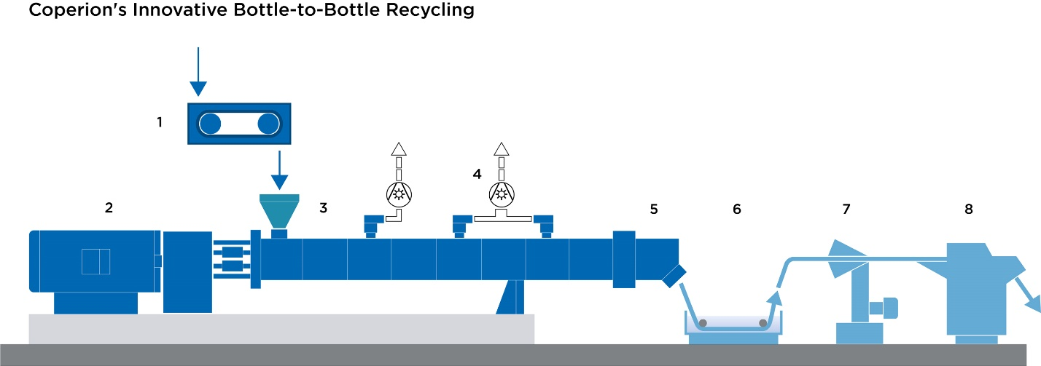
Typical set-up of a recycling system for economically processing PET flakes into PET pellets that can be used in turn to manufacture bottles
- SWB (Smart Weigh Belt) feeder
- ZSK twin screw extruder
- Addition of PET flakes
- Devolatilization of volatile components
- Discharge via gear pump and filter
- Water bath
- Strand drying
- Strand pelletizing

Image: Coperion, Stuttgart

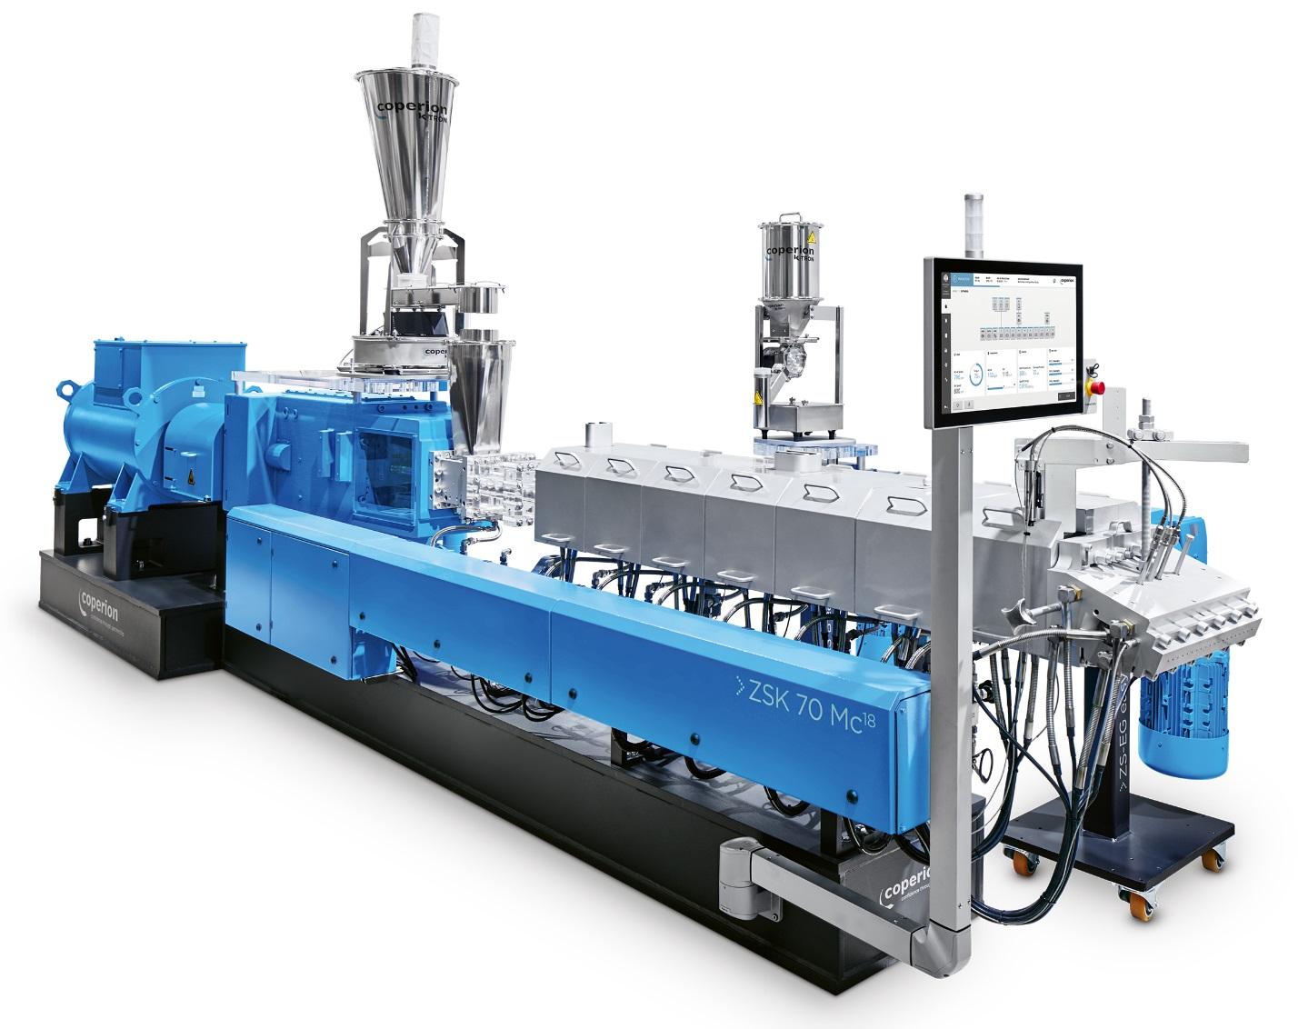
Coperion ZSK twin screw extruders provide very good devolatilization with short residence times in the process section as well as very high dispersion, contributing significantly to high end product quality.
Photo: Coperion, Stuttgart

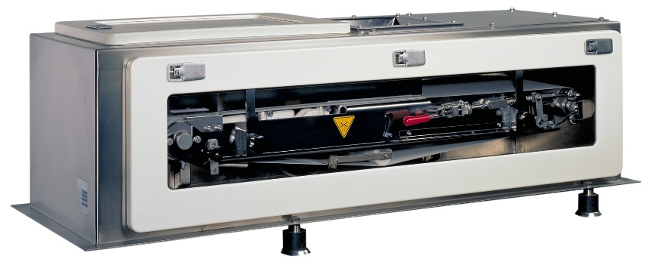
High-accuracy Coperion K-Tron SWB feeder that reliably and precisely feeds PET flakes into the extruder
Photo: Coperion K-Tron, Niederlenz, Switzerland

