Contact
Regula Sullivan
Marketing Communications
Coperion K-Tron (Switzerland) LLC
Lenzhardweg 43/45
CH-5702 Niederlenz

Tel: +41 62 885 7171
regula.sullivan@coperion.com
www.coperion.com

Press Release

Preconfigured Feeders Offer Plastics Industry A Powerful and Efficient Feeding Solution
Coperion K-Tron Announces All-New ProRate PLUS Feeder Line

Niederlenz, Switzerland (January 2022) – Coperion K-Tron is proud to announce the expansion of the original ProRate™ feeder portfolio with a completely new and cost-effective feeder line called ProRate PLUS. Answering the call from the marketplace for a robust and reliable feeder for simple feeding applications in the plastics industry, Coperion K-Tron developed a completely new feeder line built on 100 years of feeding experience. The ProRate PLUS continuous gravimetric feeder line is an economical solution and offers a quick return on investment due to its good price-performance ratio and fast delivery times. It was designed with the specific requirements of the plastics processing industry in mind. These single screw feeders are ideal for the feeding of pellets, granules and other free-flowing bulk materials in secondary plastics applications. ProRate PLUS feeders are available in three sizes and can be installed as individual units or easily arranged in cluster of up to six feeders around a process inlet, depending on the recipe formulation.
The ProRate PLUS feeder line features a unique design which allows a very compact, space-saving arrangement. The trapezoidal shape of the ProRate Plus feeders allows up to six feeders to be easily grouped around an extruder inlet within a 1.5 meter [5 ft] radius. The three feeder models PLUS-S, PLUS-M and PLUS-L cover a wide range of throughputs. The ProRate PLUS feeders are capable of handling feed rates from 3.3 up to 4800 dm³/h [0.12 up to 400 ft³/h], depending on the material. Theoretically a feeding system with six ProRate PLUS-L feeders can feed up to 28.8 m³/h [1017 ft³/h] on a footprint of only 7 m² [75 ft²].
ProRate feeders are highly standardized and include a variety of design features to optimize performance and ease of use. Simple access for cleaning and maintenance, even within a cluster, is provided thanks to a patent-pending rail system called “ProClean Rail”. ProClean Rail makes it possible to retract the base unit toward the rear of the feeder and rotate it for access to the feeding section and screw element. This allows for maintenance and cleaning of the feeding unit while keeping the feeder in position. In addition, the bellows and screw use the latest magnet technology for simple but robust mounting. The magnet connections allow these parts to be released without tools while at the same time providing the required holding force for optimal and safe operation. Thanks to the high level of standardization of the feeders, the number of spare parts required for emergency stock is minimal. Many parts are identical for all three models and can be used as exchange parts for all devices.

ProRate PLUS feeders are suitable for use in hazardous locations rated NEC Class II, Div. 2, Group F & G and ATEX 3D/3D (outside/inside).

Accurate weight measurement and reliable control modules for efficient operation
All ProRate PLUS feeders are equipped with P-SFT load cells, featuring reliable Smart Force Transducer weighing technology. They operate under compression and provide accurate, stable and reliable digital weight measurement under a broad range of operating conditions. The load cells supply a direct digital weighing signal and the onboard microcontroller ensures excellent repeatability and stability. P-SFT load cells have a high tolerance to vibration and electrical noise. They feature built-in over and underload protection.

Each feeder comes equipped with its own pre-wired ProRate PLUS PCM control module. The PCM is mounted to the feeder stand, with adjustable height positioning. Each PCM is pre-tested in Coperion K-Tron’s manufacturing facility prior to shipping. There are two models of PCM to choose from: a basic motor control unit (PCM-MD) or an advanced version with integrated user interface and line control functionality (PCM-KD). Within a group of up to eight feeders, one feeder must be equipped with the PCM-KD while the PCM-MD is sufficient for the others.

The PCM-KD comes with all the software the ProRate PLUS feeder will need for continuous applications and supports all three feeder models. Connection between weigh feeders, operator interface and smart I/O is via an industrial network. All motor setup, diagnostics and operator interface functions are integrated into the PCM-KD user interface. The PCM-KD is equipped with a host communication port (Ethernet IP or Profinet).
A variety of service offerings to keep processes running smoothly
Coperion K-Tron’s dedication to customer satisfaction has also led to the creation of a unique new portfolio of service offerings for the launch of this product line. A variety of Start-up and Service Packages are available for ProRate PLUS feeders to ensure each customer can get exactly the level of service they need. Coperion K-Tron also offers quick and easy remote services for ProRate PLUS. From an online portal to 24-hour phone support and even remote start-up assistance, trained service technicians are available to keep systems running around the globe.
In all, the brand new ProRate PLUS feeder line offers a simple, robust and reliable solution for feeding a variety of free-flowing bulk materials in plastics processing applications.

Coperion is the international market and technology leader in compounding and extrusion systems, feeding and weighing technology, bulk materials handling systems and services. Coperion designs, develops, manufactures and maintains systems, machines and components for the plastics, chemicals, pharmaceutical, food and minerals industries. Within its two divisions – Polymer and Strategic Markets / Aftermarket Sales and Service – Coperion has 2,500 employees and nearly 30 sales and service companies worldwide. Coperion K-Tron is a brand of Coperion. For more information visit www.coperion.com or email info@coperion.com.
⌘⌘⌘

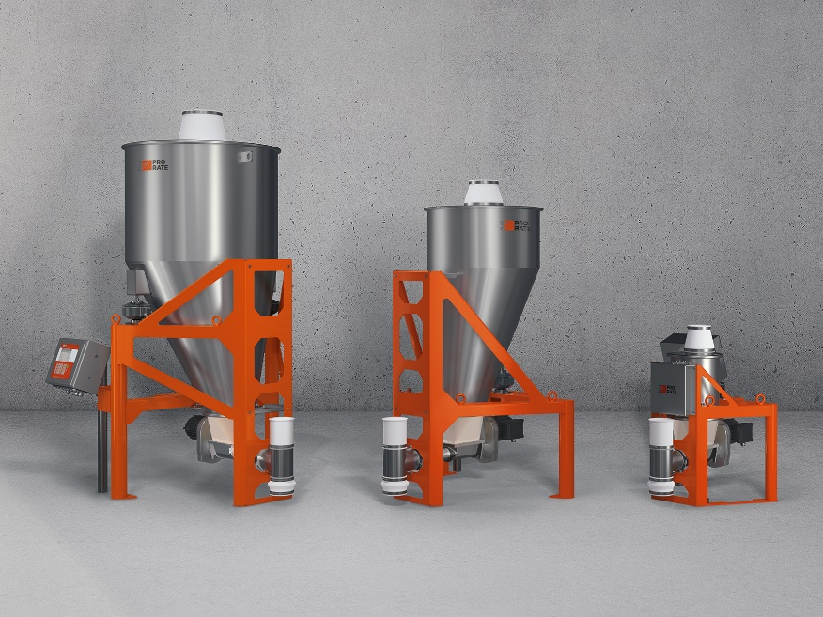
ProRate PLUS continuous single screw gravimetric feeders are ideal for the feeding of pellets, granules and other free-flowing bulk materials in secondary plastics applications.
Image: Coperion K-Tron, Niederlenz, Switzerland

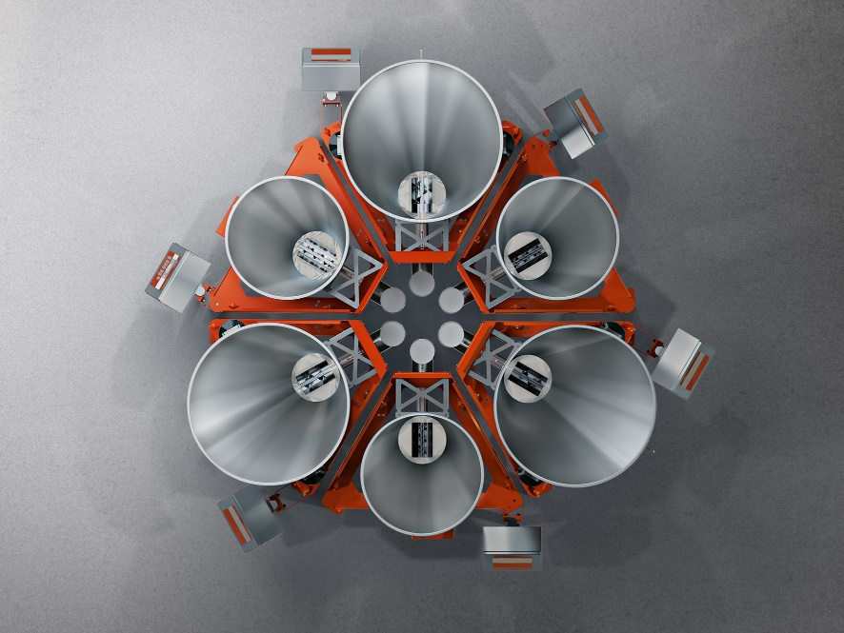
ProRate PLUS feeders can be installed as individual units or easily arranged in cluster of up to six feeders around a process inlet, depending on the recipe formulation.
Image: Coperion K-Tron, Niederlenz, Switzerland

