Contact
Kathy Burlew
Marketing Communications
Coperion K-Tron Salina, Inc.
606 N. Front Street
Salina, KS, 67401

Telephone +1 785-577-3777
kathy.burlew@coperion.com
www.coperion.com

Press Release

Coperion at Battery Show North America
Shaping Tomorrow's Energy: Cutting-Edge Technologies Enhancing Battery Manufacturing Efficiency
Sewell, NJ, USA, September 2025 – At this year’s Battery Show North America, taking place in Detroit, Michigan, October 7-9, 2025, Coperion will highlight its latest innovation - the Loss-in-Weight Roller Feeder, a precise gravimetric solution for dry electrode coating in battery manufacturing. This advanced feeder is designed to ensure uniform application, enhance process stability, and improve overall efficiency, marking a significant breakthrough in scalable, solvent-free electrode production. Attendees will have the opportunity to engage with Coperion experts and learn about the company’s latest plans how this technology can revolutionize their processes at Booth 5107. Additional focal points will be continuous extrusion capabilities that offer greater material efficiency and more cost-effective battery cell production.

Unique New Technology for Precise Active Coating Material Delivery
The new Coperion K-Tron Loss-in-Weight Roller Feeder is a state-of-the-art solution designed for continuous feeding of dry electrode coating powder blends directly into the calender gap in dry coating processes. The roller feeder is designed primarily for laboratory and pilot-scale production. The feeder is mounted on a robust platform scale utilizing high-accuracy SFT weighing technology. Its innovative dual roller design, housed within a compact enclosure, features a dynamic feeding gap that ensures gentle, consistent material handling while preventing bridging. This ensures uniform and repeatable mass distribution across adjustable widths up to 400 mm. The system’s stability and precision are essential for optimizing electrode production and achieving high-quality, scalable results. As part of an integrated manufacturing solution, the loss-in-weight roller feeder enhances process automation, material utilization, and overall productivity in cutting-edge battery production lines.

Unlocking Greater Efficiency through Continuous Dry Coating of Electrodes
Coperion’s ZSK extruder, in combination with high accuracy Coperion K-Tron screw feeders, provides an ideal solution for continuous extrusion of battery masses in dry coating applications. Its design allows for the simultaneous fibrillation binders and homogenization of raw materials. The shorter residence time in the extruder, along with precise temperature control of individual barrel sections, offers additional advantages in process flexibility — allowing thermal energy management tailored to the specific needs of battery electrode production.
The ZSK twin screw extruder offers a highly efficient solution for continuous manufacturing of dry coated electrodes, significantly optimizing the process. Automated operation ensures consistent product flow while reducing space requirements and personnel needs. Thanks to its excellent dispersive and distributive mixing capabilities, the ZSK extruder produces highly homogeneous materials, resulting in better product quality even when incorporating difficult-to-mix ingredients.
Coperion K-Tron twin screw feeders are ideal for battery electrode manufacturing processes due to their high accuracy and consistent material flow into the extruder. They ensure accurate feeding of dry electrode materials, such as active powders, conductive additives, and binders, which is critical for maintaining quality and consistency in electrode layers. Their advanced weighing technology provides real-time weight measurement, allowing for precise control of material feed rates and minimizing batch variability. These feeders are capable of handling challenging powder blends and sticky materials, which are common in electrode production. By maintaining a steady and accurate material supply, they optimize process efficiency and reduce material waste.
Coperion’s material handling solutions are tailored to meet the strict temperature requirements throughout the entire dry coating process. From conveying and feeding to handling the active material blends, Coperion supplies equipment that ensures precise temperature control and smooth processing, further enhancing efficiency and consistency in electrode manufacturing.
Battery Manufacturing Test Lab Capabilities
Coperion’s dedicated test centers, specifically designed for battery production research, provide comprehensive testing opportunities across various process steps, including pneumatic conveying, raw material handling and feeding, filtration, and continuous extrusion of battery masses. These facilities serve as ideal platforms for testing new products or process modifications. Supported by experienced Coperion experts, customers can optimize process design to maximize product quality, safety, and efficiency. The test centers accommodate all common raw materials used in active material and offer extensive simulation and scale-up expertise. A specialized research lab for hazardous substance testing is also available, ensuring a comprehensive approach to battery manufacturing innovation.

Nick Giefer, Batteries Business Unit Leader at Coperion says, “Our latest innovations, including the Loss-in-Weight Roller Feeder and advanced continuous extrusion capabilities, are designed to improve process stability, material efficiency, and scalability in battery manufacturing. These technologies help manufacturers produce high-quality, solvent-free electrodes more sustainably and cost-effectively, supporting the advancement of battery manufacturing."

About Coperion
Coperion (www.coperion.com) is a global industry and technology leader in compounding and extrusion systems, size reduction, washing, separating, drying, agglomeration, feeding, weighing, material handling and pneumatic conveying systems, as well as milling, mixing, thermal processing, dust collection and other services. Coperion develops, produces, and services plants, machinery, and components for the plastics and plastics recycling, chemical, battery, minerals, food and pharmaceutical industries. Coperion employs more than 5,000 people in its three divisions, Performance Materials, Food, Health & Nutrition, and Aftermarket Sales & Service - at over 50 sales and service locations worldwide. Coperion is an Operating Company of Hillenbrand (NYSE: HI), a global industrial company that provides highly-engineered, mission-critical processing equipment and solutions to customers serving a wide variety of industries around the world. www.hillenbrand.com



Dear Colleagues,
You can find and download this press release in English and print-ready color images at
https://www.coperion.com/en/news-media/newsroom/
.
Editorial contact and copies:
Dr. Jörg Wolters, KONSENS Public Relations GmbH & Co. KG,
Hans-Böckler-Str. 20, D - 63811 Stockstadt am Main, GERMANY
Tel.: +49 (0)60 27/ 99 00 5-0
E-Mail: mail@konsens.de, Internet: www.konsens.de

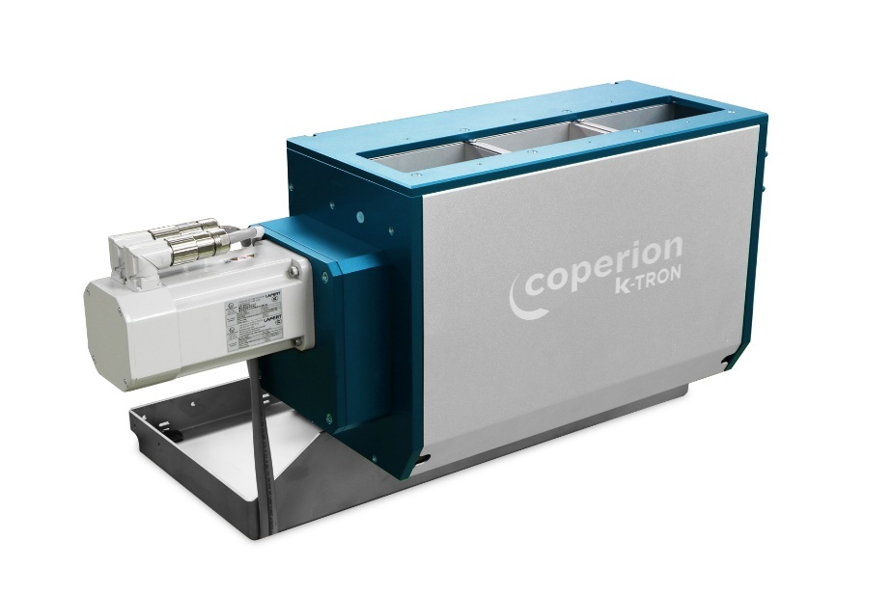
Coperion K-Tron Loss-in-Weight Roller Feeder for Dry Coating Electrode Manufacturing Processes
Photo: Coperion, Niederlenz, Switzerland

